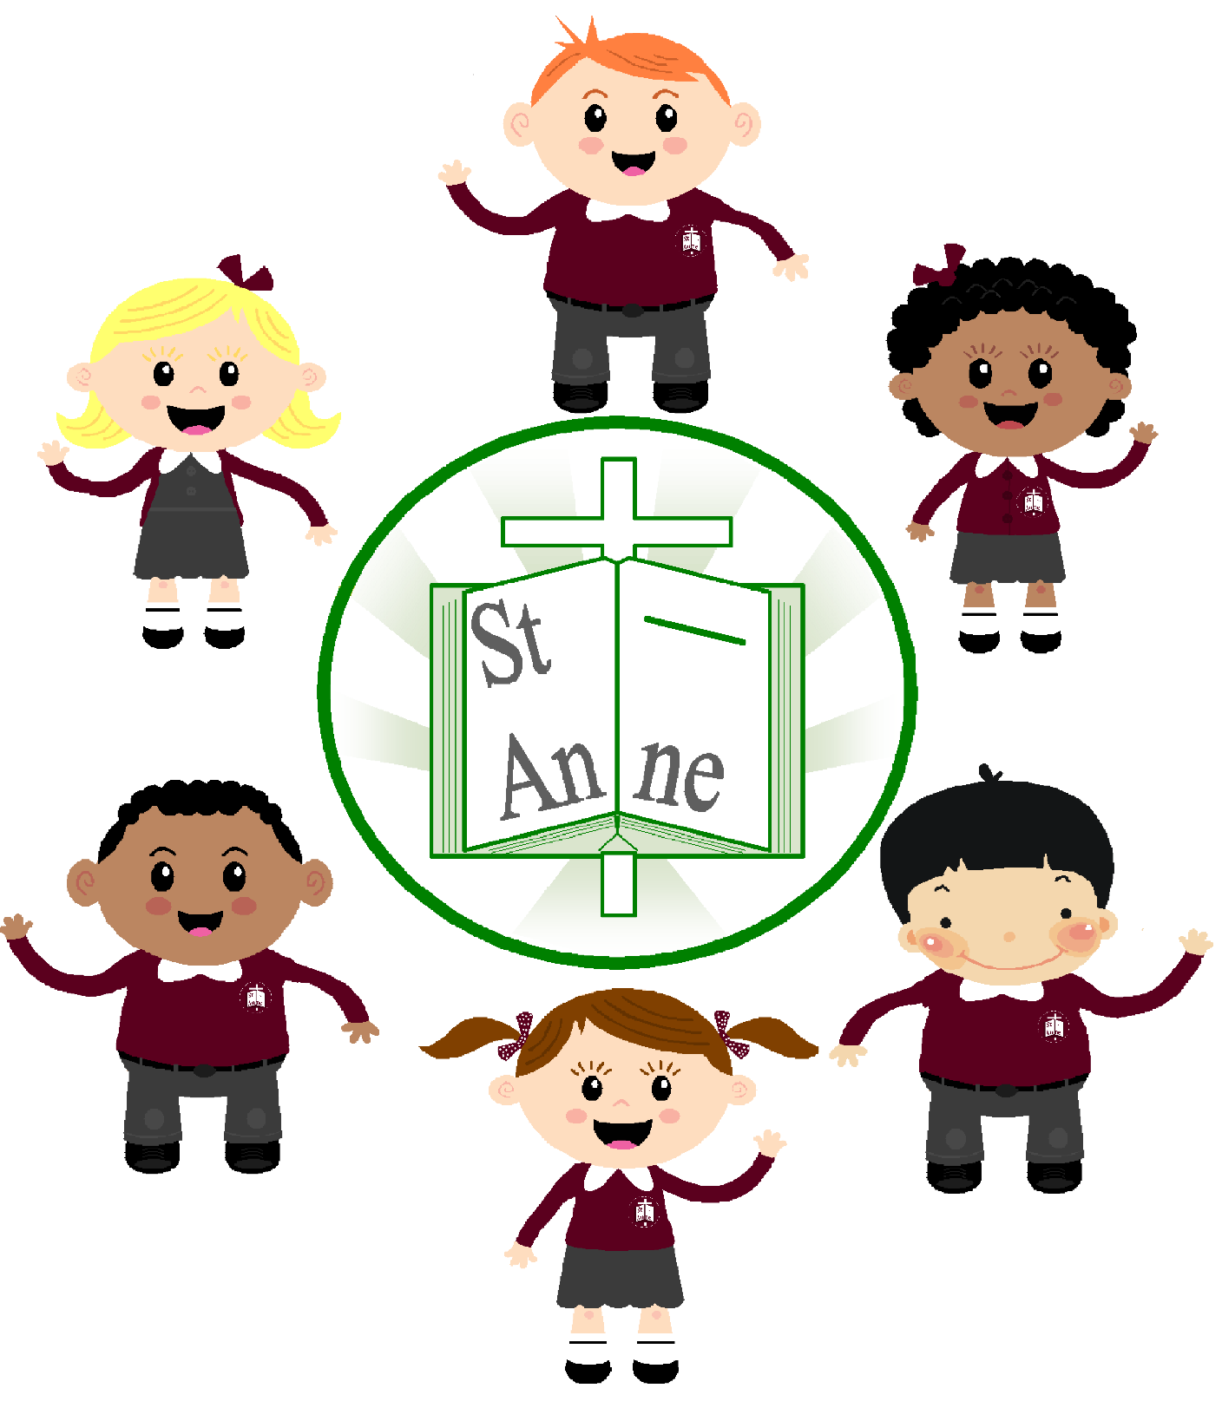

St. Anne (Stanley) C of E School
Phonics Policy

A Baseline for Achieving Excellence in Phonics

September 2025
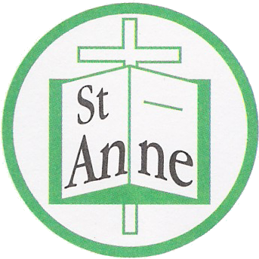

St Anne (Stanley) CE School

Phonics Policy 2025

- Intent

Curriculum Vision

At St Anne (Stanley) CE Primary School we strive to ensure that all children become successful, fluent readers by the end of Key Stage One and believe this is achievable through a combination of strong, high quality, discrete phonics teaching combined with opportunities for children to listen to a range of books read by an adult to promote fluency and language comprehension through a whole language approach that ensures a ‘Reading for Pleasure’ culture.
‘Phonics provides pupils with the building blocks they need to read fluently and confidently, as well as aiding future learning and giving them the tools they need to express themselves.’ (Nick Gibb, Schools Standards Minister 2018)

Aims of subject

St Anne (Stanley) aims to reinforce a consistent, high quality approach to the teaching of phonics across the Early Years Foundation Stage, (EYFS,) Key Stage One and on into Key Stage Two for children who still need this further support.
Our main aims are:
- To teach children aural discrimination, phonemic awareness and rhyme to aid reading, writing and spelling development.
- To encourage the use of segmenting and blending so that decoding skills provide a sound foundation for reading, writing and spelling.
- To ensure the teaching of phonics is lively, interactive and investigative.
- To enable children to use phonic awareness across the curriculum.
- To ensure that children know the 44 phonemes within the English language.
- To teach children to recognise the graphemes within words and associate them with the appropriate phoneme when reading.
- To provide children with strategies to identify and decode ‘tricky words.’

School Values

In St Anne (Stanley) we aim to provide a caring, happy and safe environment in which the school values of Honesty, Friendship, Understanding, Hope, Confidence and Family are upheld and embedded across the curriculum. This means that in Phonics:
- We support each and every child to become confident in their ability to use phonics as a method of reading and writing
- We teach them to understand the importance of Phonics as a basis for their reading and writing skills.
- We give them hope to strive for the best they can be and attain to their highest achievements.
- We work together with family and friends to ensure we understand what we need to do to become confident, enthusiastic readers and writers.

Cultural capital

‘The ability to read is the key to educational achievement. Without a basic foundation in literacy, children cannot gain access to a rich and diverse curriculum. Poor literacy limits opportunities not only at school, but throughout life, both economically and in terms of a wider enjoyment and appreciation of the written word’. (Education and Skills Committee)
Therefore, in St Anne (Stanley) we belief that all children should get the best teaching possible in this crucial area so we will deliver the important skills and knowledge of phonics through a combination of strong, high quality, discrete phonics teaching combined with a whole language approach which will ensure all children achieve and succeed to their highest potential.

Planning and sequencing

Reading
We begin by teaching the children set 1 sounds. Children can start blending sounds into words as soon as they know a small group of letters well. Once the children have been taught the first 5 sounds (m, a, s, d, t), they are then taught assisted blending using the sounds that they know. During lessons children are taught to hear sounds and blend them together in sequence to make a word. We start with blending oral sounds, then progress to reading the letters and blending them together to read the word.
Order of teaching sounds
In Read Write Inc. phonics the individual sounds are called ‘speed sounds’ – because we want every child to read them effortlessly. Set 1 sounds are the single letter sounds and set 1 special friend sounds. They are taught in the following order;
m, a, s, d, t, i, n, p, g, o, c, k, u, b, f, e, l, h, r, j, v, y, w, z, sh, qu, th, ng, ch, nk, ck
There are 12 Set 2 ‘speed sounds’ that are made up of two or three letters which represent just one sound, e.g. ay as in play, ee as in tree and igh as in high. These are ‘special friend’ sounds.
When children are taught Set 2 sounds they will learn:
- a simple picture prompt linked to the sound
- a short phrase to say e.g. may I play
- the letters that represent a sound (special friends) e.g. ay
Each sound has a list of green words linked to it, so that the children have the opportunity to sound out and blend words containing the new sound they have been taught, for example, s-p-r-ay = spray.
When learning Set 3 speed sounds the children will be taught alternative sounds/graphemes, e.g. ee as in tree and ea as in tea.
Nonsense words (Alien words)
As children build up their knowledge of sounds they are able to apply their decoding skills to any unfamiliar word, whether it be real or nonsense. During lessons each day children will practice their decoding skills by sounding out nonsense words. Children are unable to rely on existing knowledge of real words, and instead have to use their letter-sound knowledge. This is an important part of the Phonics Screening Check that the children complete at the end of year 1.
Learning to blend and Ditty Books
As soon as children have been taught a few initial letter sounds they begin to learn to blend the sounds together to read real words in a Word Time session. Each word time session involves oral blending of known sounds before they are shown the words written down on green cards. Children practice Fred talking the words until they become able to read them on sight. Ditty lessons follow on from this where children who are becoming excellent at reading single words are introduced to reading short sentences. Once children are confident reading the short sentences they are challenged to use their developing phonic knowledge to write a sentence.
Storybook Lessons
After ditty books, the next stage is storybooks. These books are closely matched to their developing phonic knowledge. The storybooks consist of green words linked to the sounds that they have been learning, red words and challenge words to extend the children’s vocabulary. After children have practiced these words individually they are prepared to see them in context in the story. Comprehension activities, partner discussion and writing activities based on the book, follow on from reading.
Reading into writing
Through the storybooks, there is a key focus on consolidation to ensure that children have the opportunities to practise and embed their phonic knowledge, building on their knowledge and understanding to apply these skills in their independent reading and writing. Each story book follows a three or five day plan.
Writing activities include;
- ‘Hold a sentence’ which encourages the children to remember a whole sentence while focusing on spelling and punctuation
- ‘Build a sentence’ which gives the children the opportunity to create their own sentence to that shows the meaning of a word
- ‘Edit a sentence’ which allows the children to critique a sentence using their knowledge of spelling, punctuation and grammar.
Children then complete a longer piece of independent writing, which gives them the opportunity to show off their creativity and to practice their spelling, grammar and punctuation.
Curriculum map

We follow the Read Write Inc. Progression Map across our school and know the minimum expectations our children at St Anne (Stanley) will achieve in each year group in phonics and early reading
All children should achieve these expectations (updated January 2025) if they have followed the programme from Reception.

 | Reception | Year 1 | Year 2
End Autumn 1 | Read 16 single-letter Set 1 sounds | Read 47 sounds (all set and 2 sounds)  Read Purple Storybooks; | Read Blue Storybooks with increasing fluency and comprehension
End of Autumn Term | Read all 25 Set 1 sounds;  Blend sounds into words orally | Read 52 sounds Including first 5 set 3 sounds  Read Pink Storybooks | Read Grey Storybooks
End of Spring 1 | Read all 25 Set 1 sounds;  Blend sounds to read words  Read short Ditty stories | Read 58 sounds including 11 set 3 sounds  Read Orange Storybooks | Read Grey Storybooks  With increasing fluency and comprehension
End of Spring Term | Read 31 sounds including set 1 special friends  Read Red Storybooks | Read 64 sounds including 17 set 3 sounds  Read Yellow Storybooks | Access RWI Comprehension and Spelling programmes
End of Summer 1 | Read 35 sounds including 4double consonants  Read Green Storybooks; | Read 69 sounds including 22 set 3 sounds  Read Yellow Storybooks | Access RWI Comprehension and Spelling programmes
End of Summer Term | Read 41 sounds including first 6 set 2 sounds  Read Green Storybooks | Read 75 sounds including all set 3 sounds and additional graphemes  Read Blue Storybooks | Access RWI Comprehension and Spelling programmes

Schematic links

At St Anne (Stanley) we recognise that Phonics teaching is the basis of ensuring that; ‘Teachers should develop pupils’ spoken language, reading, writing and vocabulary as integral aspects of the teaching of every subject. English is both a subject in its own right and the medium for teaching; for pupils, understanding the language provides access to the whole curriculum. Fluency in the English language is an essential foundation for success in all subjects’. (DfE (September 2013) The National Curriculum in England (Framework Document), p10. London: DfE, © Crown Copyright 2013.)

2. Implementation

High quality teaching and learning

In St Anne (Stanley) we use a systematic, structured phonics programme called Read Write Inc. Phonics.

Read Write Inc. is divided into set sounds and storybooks with each phase building on the skills and knowledge of previous learning. Children have time to practise and rapidly expand their ability to read and spell words. They are also taught to read and spell ‘red words’ (tricky words), which are words with spellings that are unusual and cannot be segmented or blended (sounded out).

Through the storybooks, there is a key focus on consolidation to ensure that children have the opportunities to practise and embed their phonic knowledge, building on their knowledge and understanding to apply these skills in their independent reading and writing.

Children use phonic knowledge when they are reading and writing. This approach has been shown to provide a quick and efficient way for most young children to learn to read and write words on the page, fluently and accurately. We want children to develop this skill so that it becomes automatic. This also helps them with their spelling.

Planning for phonics is done separately from English but with the understanding that good phonics teaching should link to the literacy needs of the children within an English lesson and across the curriculum.

Opportunities to develop subject specific literacy – oracy and vocabulary:

At St (Anne Stanley), we ensure that all staff are trained in the application of Read Write Inc. and in the correct pronunciation of all phonemes. We consistently use the terminology with the children based on the Scheme as this helps them to understand the whole process. We use the terms Special Friends, Fred Talk and Read the Word.
The technical terms, such as: Blending, Decoding, Digraph, Grapheme-Phoneme Correspondences (GPCs), Homograph, Phoneme, Segmenting, Split Digraph and Trigraph are known by the adults teaching.

We provide a rich and varied environment that supports children’s language learning through Phase One and beyond and include photographs and captions to encourage children to explore and apply the knowledge and skills to which they have been introduced through the activities. We encourage adults and children to listen and speak to each other which helps them to use more relevant, language. As a staff we model good listening which includes making eye contact with speakers, asking questions and commenting on what has been said.
We give children ample opportunities to extend their spoken communication. All staff provide good models of spoken English to help the children enlarge their vocabulary and learn how to structure comprehensible sentences, speak confidently and clearly, and sustain dialogue.

Progress-knowing more and remembering more

To guarantee that progress is made for all children in Phonics, the staff at St Anne (Stanley) ensure that we follow the teaching sequence for Read Write Inc. phonics. All children are given the opportunity to recap on previous learning as part of this daily sequence of learning. We are able to embed the knowledge required in the teaching sequence and through lively and interactive lessons. We consistently build on the children’s prior learning to deepen their understanding and build confidence in their own ability to be able to read and write independently.

Assessments

At St Anne (Stanley) the purpose of monitoring and evaluation activities is to raise the overall quality of teaching and levels of pupil attainment. The Phonics Lead and the Head teacher will monitor the quality of teaching and learning throughout the school through lesson observations, learning walks, pupil voice and assessment of teacher data.

Every half term, the Phonics Lead will assess the children’s understanding and knowledge of phonics. The half-termly assessments ensure that the children are grouped effectively so that they all make sufficient progress. In the EYFS and KS1 we assess pupil progress through the RWI Portal Online assessments and plot the children on a Phonics tracker grid. This data is collated by the Phonics Lead and a report written to identify specific skills or any gaps in learning. The staff use this to plan and deliver well differentiated lessons that engage and challenge all children within the lesson. This assessment informs the rate at which children progress through the phases and secure a sound understanding of phonics and will identify particular areas of need in terms of support and intervention to ensure all children reach the expected standards. Children not meeting age related expectations are targeted for small group work or 1-1 tuition.

All Year 1 children take the Phonics Screening Check - a statutory assessment required by legislation. Those who do not meet the pass mark will be given support and intervention programmes in Year Two such as 1-1 Tutoring to provide them with sufficient knowledge and understanding to re-take the Phonics Screening Check and obtain a pass mark. Those children who do not obtain the required level set by the Phonics Screening Check will receive phonics teaching in the first term of year three – which will be further supported throughout the year and across Key Stage Two with a phonics and/or spelling intervention programme

Learning environment

At St Anne (Stanley) we stress an importance of phonics within the learning environment and ensure that it is paramount and evident within all areas of learning. In EYFS and KS1, teachers ensure the classroom and outdoor environment has an age appropriate display of all grapheme-phoneme correspondences related to Read Write Inc. phonics. Red (Tricky) words will also be displayed and referred to. In KS2 there will be a complex sounds display to ensure they can use their phonics in spellings and beyond. A Learning Wall is used to display that week’s learning using any key words as well as the grapheme-phoneme being taught. Children are able to constantly refer to this within their day for consolidation and application of previous phonics taught. Correct letter formation information is displayed within every classroom environment.

Reading

Phonics is the most widely used approach to teaching reading and spelling. It is an integral part of all children being able to read in St Anne (Stanley). We ensure that children are taught the skills necessary through strong, high quality, discrete phonics combined with opportunities for children to listen to a range of books read by an adult to promote fluency and language comprehension through a whole language approach that ensures a ‘Reading for Pleasure’ culture. Children are given home reader books from our Read Write Inc. scheme in EYFS and KS1 that are fully matched to their phonic learning. In KS2, children progress onto books from our Oxford Reading Tree scheme that are compatible with their deepening phonic understanding. All children are given the opportunity to read a variety of fiction and non-fiction books that they can read for pleasure in class and at home with the support of adults if required. The ability to read is embedded throughout the curriculum at St Anne (Stanley) and the children are given many opportunities to develop their understanding through a rich and diverse programme of learning.

Inclusion

SEND

At St. Anne (Stanley), we aim to create a fully inclusive, person centered environment which reflects the values of our Church of England faith. The views and needs of the child and their families/carers are at its heart to encourage a strong focus on high aspirations and on improving outcomes for children with SEND, to enable them to succeed in their education and make a successful transition into adulthood.

We will consider the following approaches in our teaching of Phonics to children with SEND.

- Maintain an inclusive learning Environment considering the following:
- Sound and light
- Seating
- Resources
- Displays

- Multi-sensory approaches considering the following:
- Learning styles
- Use of ICT

- Working with additional adults considering the following:
- Consulting children
- Planning support
- Evaluation

- Managing peer Relationships considering the following:
- Grouping pupils
- Managing group work and discussion
- Developing responsibility

- Adult-Pupil communication considering the following:
- Teachers’ communication
- Children’s communication
- Child-teacher interaction

- Formative assessment considering the following:
- Understanding the aims of the lesson
- Focus on how children learn
- Children know where they are in relation to the aims
- Giving feedback
- Understanding assessment criteria
- Reviewing progress and helping children to improve
- Gathering assessment evidence

- Motivation considering the following:
- Understanding the structure of the lesson
- Relevant and motivating tasks
- Reward systems

- Memory/consolidation considering the following:
- Pre-teaching of key vocabulary
- Recap of Prior learning and vocabulary
- Reducing resilience on memory
- Consolidating learning

Staff will plan for and utilise resources that take into account all learning styles, including visual, auditory and kinaesthetic learners. Resources such as magnetic whiteboards and letters, sound cards and sound mats will be evident during phonic sessions. All activities will be firmly focused on achieving the intended learning outcome.

Children are grouped according to their ability in Phonics so that they are given the chance to succeed. Careful thought will be given to the provision of appropriately structured work for children with SEN, often through intervention groups or 1-1 tuition. The school uses a variety of strategies to enable children to have increased access to the curriculum through a broad-based, multi-sensory, visual, auditory and kinaesthetically planned phonic sessions.

More able, gifted and talented

All staff at St Anne (Stanley) have high expectations of each and every child but we also ensure that able, gifted and talented children have opportunities provided that develop and apply their particular capabilities. We provide experiences that encourage all pupils to think creatively, explore and develop ideas, and try different approaches throughout all of their curriculum subjects.

EAL

All pupils at St. Anne (Stanley) need to feel safe, accepted and valued in order to learn. For pupils who are learning English as an additional language, this includes recognising and valuing their home language and background. As a school, we are aware that bilingualism is a strength and that EAL pupils have a valuable contribution to make in Phonics. We take a whole school approach, including ethos, curriculum, education against racism and promoting language awareness in his subject.

Pupils learning English as an Additional Language are entitled to the full National Curriculum Programmes of Study and at St. Anne (Stanley) we will ensure all EAL pupils will achieve the highest possible standards by taking into account each child’s life experiences and needs so they can succeed in Phonics.

As soon as a child enters St Anne (Stanley) we ensure that they are given the skills to be able to function and work within our school through teaching them synthetic phonics at a level that is appropriate for them. This is done either through whole class teaching, small group interventions or 1-1 interventions. Synthetic phonics and the development of phonological awareness supports EAL children with their reading development and many EAL learners develop the ability to decode rapidly but we also ensure we provide other activities which support the language and literacy development of EAL children.

SMSC/British values

In St Anne (Stanley) we ensure that we promote the spiritual, moral, social and cultural (SMSC) development of every child. As part of this, we actively promote the fundamental British values of:
- Democracy
- The rule of law
- Individual liberty
- Mutual respect for and tolerance of those with different faiths and beliefs

SMSC plays a significant part in a child’s ability to learn and achieve. Phonics is an integral part of the curriculum and it therefore makes a contribution to the child’s spiritual, moral, social and cultural development. All adults will model and promote expected behaviour during phonics lessons, treating everyone as a valuable individual and showing respect for children and their families. Children will understand the need for rules and the need to abide by them for the good of everyone. School and classroom rules reflect, reiterate, promote and reward acceptable behaviour and provide opportunities to celebrate children’s work and achievements in phonics.

Enrichment

An after-school phonics club is available for children in year 1. This is to support children who require additional support to retain the phonemes already learnt in class. The children engage in fun, exciting ways of learning with an emphasis on children’s active participation. We also ensure that each child is given the opportunity to read for pleasure in school and at home.

Homework

A weekly information letter/email is sent out from Nursery, Reception and Year 1 to inform parents about the learning that has been taking place in Phonics which also includes links to the Read Write Inc. Phonic videos that have been learnt that week. Parents can use this information to work on phonemes and tricky words at home. An information booklet is also provided which details the different phases of phonics and how parents can help their child at home. Children are given words every week to practise at home and they are supplied with home reading books that should be read multiple times to support fluency and comprehension.

Every child in St Anne (Stanley) is given the opportunity to take home a reading book. Each child’s reading level has been carefully decided by the Phonics Lead through regular assessment.

3. Impact: what will our children look like?

In St Anne (Stanley) Phonics is used as an approach to teach reading, and some aspects of writing. This is done by developing children’s phonemic awareness through strong, high quality, discrete phonics. Children are taught the skills of hearing, identifying and using phonemes in English. We aim to systematically teach children the relationship between these sounds and the written spelling patterns, or graphemes, which represent them. Phonics emphasises the skills of decoding new words by sounding them out and combining or ‘blending’ the sound-spelling patterns. Our effective phonics techniques are embedded within a rich literacy environment

Phonics is taught daily in EYFS and KS1 and children are grouped to enable all abilities to succeed. Through teaching Phonics, we aim to nurture in the children a love of literature and language and the confidence to continue reading and writing throughout their lives. In St Anne (Stanley) we want our children to:

- read fluently for both pleasure and information.
- use spelling rules, phonics and grammar accurately.
- read and write clearly and with confidence in any given genre.
- speak clearly and confidently in any situation.
- listen actively and respond appropriately, developing knowledge and opinion.
- be able to proofread their own work and make amendments and improvements.

Michelle Sargent (Phonics Lead Coordinator)
September 2025

Date of next review June 2026

