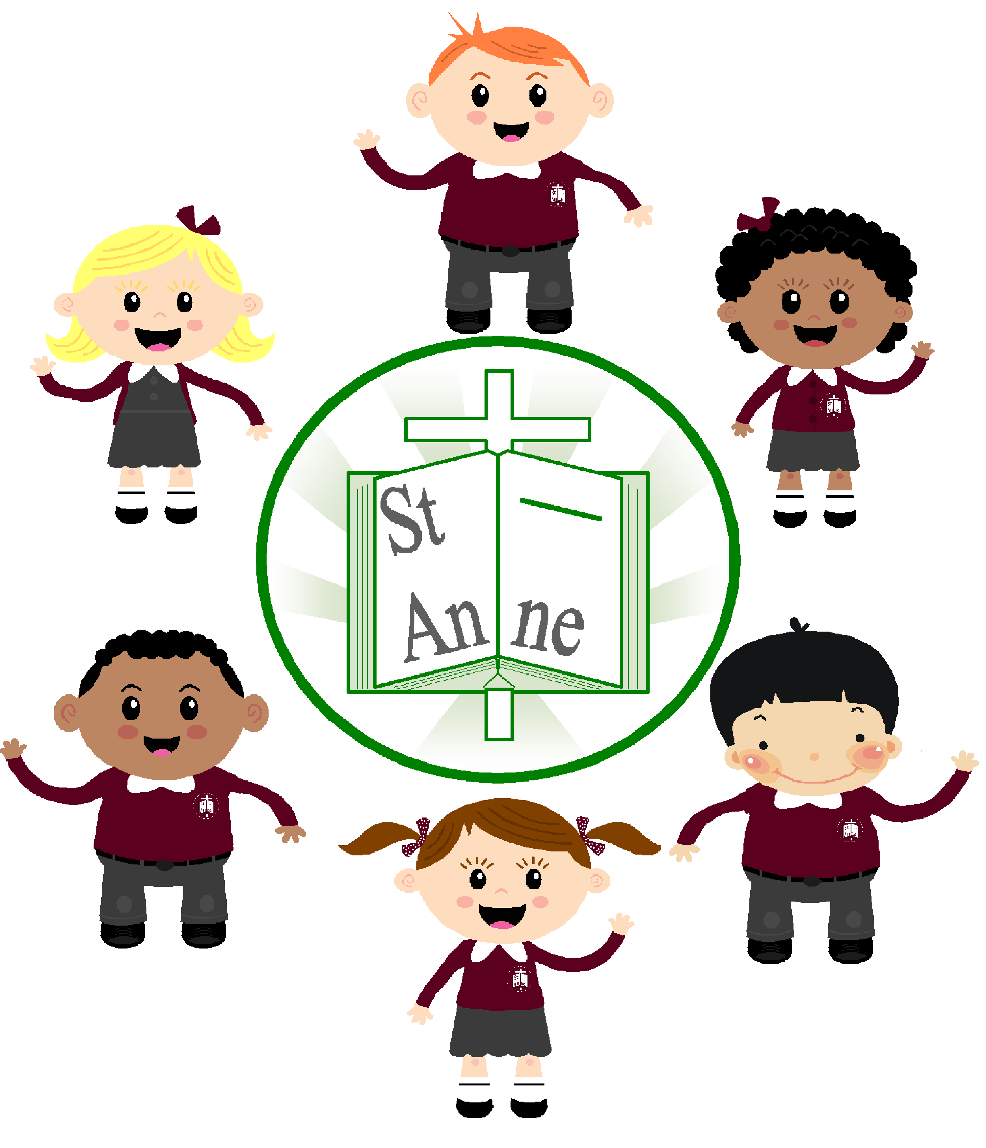

St. Anne (Stanley) C of E School
Design and Technology Policy
A Baseline for Achieving Excellence in Design and Technology

December 2021

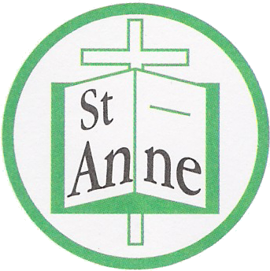

St Anne (Stanley) CE School

Design and Technology Policy 2021

- Intent

Curriculum Vision

St Anne (Stanley) CE School is a school where Design and Technology prepares children to participate successfully in tomorrow’s rapidly changing technologies by encouraging them to become creative, imaginative problem solvers through real life and relevant problems, working individually and as part of a team. We want the children to take risks through planning, designing and making in order to become resourceful, innovative, enterprising and capable citizens who will be able to reflect on, learn from and evaluate past and present design technology in order to understand its impact on daily life and the wider world.

Aims of subject

St Anne (Stanley) aims to encourage an understanding of Design and Technology in order to perform everyday tasks confidently and to develop the creative, technical and practical capabilities of each child so that they are able to participate successfully in an increasingly technological world.
In order to do this, we aim to:
- Recognise the importance of Design and Technology as an integral part of the whole school curriculum for every child regardless of race, gender and ability.
- Provide a structural approach to Design and Technology which ensures all children build and apply a range of knowledge, understanding and skills through progression and differentiation according to individual needs with a balance of open ended Design and Make activities(DMA), Focussed Practical Tasks(FPT) and Investigative, disassembly and evaluative activities(IDEAS).
- Ensure that opportunities are provided for children to critique, evaluate and test their ideas and products and to express their thoughts in a positive manner knowing that they will be valued.
- Instil positive health, safety and hygiene attitudes and satisfaction.
- Understand and apply the principles of nutrition and learn how to cook.

School Values

In St Anne (Stanley) we aim to provide a caring, happy and safe environment in which the school values of Honesty, Friendship, Understanding, Hope, Confidence and Family are upheld and embedded across the curriculum. This means that in Design and Technology:
- We support each and every child to become confident to have a go and share our ideas with others;
- We teach them to understand the task, different needs of users of the final product and being able to use a variety of tools safely;
- We give them hope to strive for the best they can be and attain to their highest achievements;
- We share our skills we have learnt and the final product with our friends and family;
- We ensure we are honest about our finished product through our evaluations.

Cultural capital

In St Anne (Stanley) CE School we want to ensure that the breadth of experiences we provide in Design and Technology raise the aspirations of each and every child and help them gain the most from their lives. We will maximise opportunities to apply and build on subject knowledge and wider skills in Design and Technology so that all children can participate successfully in tomorrow’s rapidly changing technologies through wide, rich and challenging first hand experiences. We will encourage them to become creative, imaginative problem solvers through real life and relevant problems, working individually and as part of a team. The children will consider their own needs, wants and values and will take risks through planning, designing and making. They will become resourceful, innovative, enterprising and capable citizens who will be able to reflect on, learn from and evaluate past and present design technology in order to understand its impact on daily life and the wider world.

Planning and sequencing

At St Anne (Stanley) Design and Technology will be taught discretely in KS1 and KS2 using the objectives from the Programmes of Study as outlined in the National Curriculum in England (DFE 2013) through Projects on a Page and supplemented by videos and lessons from Kapow Primary. The Early Years Foundation Stage will use the objectives set out in the Early Learning Goals, and Expressive Arts and Design to provide opportunities to demonstrate their learning of Design and Technology through topic work.
Design and Technology is taught in blocked units of work encompassing the main features of Mechanisms, Textiles, Structures, Electrics and Food and Nutrition. Each year group will follow the long term curriculum plan for Design and Technology which maps out the units covered in each term. We also build planned progression into the scheme of work, so that the children are increasingly challenged as they move through the school. Teachers then plan a medium term plan which gives details of each unit of work for each term and a series of lessons which identify learning objectives and outcomes for each unit, and ensure an appropriate balance and distribution of work across each term. This ensures all children build and apply a range of knowledge, understanding and skills through progression and differentiation according to individual needs with a balance of open ended Design and Make activities(DMA), Focussed Practical Tasks(FPT) and Investigative, disassembly and evaluative activities(IDEAS).
Each lesson will follow a structured approach of:

- Investigating/Researching
- Designing
- Making
- Evaluating

Curriculum map

TERM | Autumn 1 | Autumn 2 | Spring 1 | Spring 2 | Summer 1 | Summer 2
EYFS | Expressive Arts and Design:  Birth to 3 year olds will: Explore different materials, using all their senses to investigate them. Manipulate and play with different materials. Use their imagination as they consider what they can do with different materials.  3-4 year olds will: Explore different materials freely, to develop their ideas about how to use them and what to make. Develop their own ideas and then decide which materials to use to express them. Join different materials and explore different textures. Create closed shapes with continuous lines and begin to use these shapes to represent objects. Draw with increasing complexity and detail, such as representing a face with a circle and including details.  In Reception: Create collaboratively, sharing ideas, resources and skills.
Year 1 |  | NC. Mechanisms: Wheels and axles  Make a vehicle |  | NC. Mechanisms: Sliders and Levers  Making a moving story book |  | NC. Food and Nutrition: Preparing fruit and vegetables  Fruit salad
Year 2 |  | NC. Textiles: Joining fabrics  Making a puppet (sewing) |  | NC. Food and Nutrition: Regional/UK food  Scouse |  | NC. Freestanding structures:  Baby Bears Chair
Year 3 |  | NC. Food and Nutrition:  Healthy and varied diet:  Sandwiches (making bread) |  | NC. Textiles: 2D shape to 3D product  Cushions |  | NC. Mechanical systems: Levers and linkages  Moving monster
Year 4 |  | NC. Food and Nutrition: Healthy and varied diet (Mediterranean dish)  Vegetable Paella |  | NC. Electrical systems: Simple circuits and switches:  Torches |  | NC. Shell Structures: Computer aided design  Castles
Year 5 |  | NC. Food and Nutrition:  Celebrating culture and seasonality. (compare healthy food)  Healthy ‘Happy Meal’  Fish Burgers/ Meatballs/Chicken Nuggets(Veg - Bean burgers): |  | NC. Frame Structures  Pavilions |  | NC. Electrical systems: More complex switches and circuits:  Electronic card
Year 6 |  | Textiles: Combining different fabric shapes:  Waistcoats |  | Food and nutrition: Celebrating culture and seasonality. Cooking on a budget (food from distant places)  Jambalaya |  | Mechanical systems: gears and pulleys  Automato toys

Schematic links

Design and Technology contributes to many areas of the curriculum at St Anne (Stanley) but links particularly well in:
English
Design and Technology contributes to the teaching of English in St Anne (Stanley) by providing valuable opportunities to reinforce what skills the children have been learning in their English lessons. Through discussions the children will learn to justify their own views and clarify their design ideas, evaluating their products will allow them to articulate their ideas and compare and contrast their views with other children and adults. They will be able to write instructions, descriptions and accounts of how they made something.

Maths
Maths links extremely well into Design and Technology through carrying out surveys about products and creating charts to represent the data collected, using position and direction and standard and non-standard measures, applying their knowledge of 2D and 3D shapes and nets and understanding ratios and mass.

Computing
Computing is a fundamental part of Design and Technology and can be used to take photographs of the making process, digital graphics and text can be added to finished products, technology can be used purposefully to create and manipulate digital con tent and the children can express themselves and develop their ideas using a range of ICT resources.

Science
Through Design and Technology, children will be taught about scientific aspects such as a balanced diet and how to keep healthy, the properties of different materials they may use that make them suitable or unsuitable for particular purposes, asking simple questions and observing what happens and planning scientific enquiries to answer questions related to their product.

Art and Design
Children will be able to use and develop their drawing skills in Design and Technology, use colour, pattern, texture, line and shape when designing products, use a range of media and materials creatively to design and make products and investigate methods of adding colour and texture to textiles as well as creating their own textiles.

2. Implementation

High quality teaching and learning

At St Anne (Stanley) Design and Technology will be taught through the Programmes of Study as outlined in the National Curriculum in England (DFE 2013) and Early Years Foundation Stage (2021).
For Foundation Stage we encourage the development of skills, knowledge and understanding of Design and Technology to help the children make sense of their world through expressive arts and media as an integral part of the school. We relate their development to the Development Matters so that they meet the Early Learning Goals as Design and Technology makes an important contribution in all seven areas of learning. When designing and making products through these early experiences, children will think about: User, purpose, function and aesthetics by being taught procedures for safety and hygiene, developing practical skills and techniques using a range of materials (food, textiles and construction materials), developing their knowledge and understanding in relation to mechanisms and structures, working with food and textiles, exploring and using a range of construction kits, asking questions about existing products, exploring the designed and made world through the indoor and outdoor environment and role-play and learning and use appropriate technical vocabulary linked to all their design and technology activity.

For Key Stage 1 and 2 we use the Projects on a Page Scheme designed by the Design and Technology association (DATA) and supplement this with videos and lessons from Kapow Primary. The lessons are adapted by the class teacher where necessary, to meet the needs of our school and children through the medium term plans. These are reviewed and assessed by the Design and Technology Coordinator. The topics are taught discretely every term but will link to other subjects as appropriate. The activities build upon prior learning of the children and they are given the opportunity to develop their skills, knowledge and understanding so that they are able to progress throughout the school and become increasingly challenged. The children will design, make, evaluate and use technical knowledge and understanding through:
Investigative, disassembly and evaluating activities (IDEA): Children will examine existing products closely and discuss the processes involved so that the can discuss what they like and don’t like about the product.

Focused Practical Tasks (FPT): Children will be given short specific tasks that concentrate on extending children’s experience and knowledge of a range of materials and techniques which will enhance their manipulative skills.

Design and Make Assignment (DMA): Children are given structures projects which are more open-ended in nature so that children are given the opportunity to apply the skills and knowledge learnt during the shorter specific tasks.

Opportunities to develop subject specific literacy – oracy and vocabulary:

At St Anne (Stanley) CE School we provide a rich and varied environment that supports children’s language learning through Design and Technology and beyond. We ensure that subject specific vocabulary is displayed in the classroom and word mats are provided to support children to work independently. We encourage the children to explore and apply the knowledge and skills to which they have been introduced through the activities. We encourage adults and children to listen and speak to each other which helps them to use more relevant, language. As a staff we model good listening which includes making eye contact with speakers, asking questions and commenting on what has been said.
We give children ample opportunities to extend their spoken communication. All staff provide good models of spoken English to help the children enlarge their vocabulary and learn how to structure comprehensible sentences, speak confidently and clearly, and sustain dialogue.

Progress-knowing more and remembering more

To guarantee that progress is made for all children in Design and Technology, the staff at St Anne (Stanley) ensure that we follow the teaching sequence for Design and Technology supported by Projects on a Page. We are able to embed the knowledge required through the teaching sequence and provide relevant and investigative lessons and experiences. We consistently build on the children’s prior learning to deepen their understanding and build confidence in their own ability to be resourceful, innovative and enterprising individuals. To ascertain the children’s prior and continuing knowledge, teachers plan for quizzes and games to check children’s understanding.

Assessments

At St Anne (Stanley) the purpose of monitoring and evaluation activities is to raise the overall quality of teaching and levels of pupil attainment. The Design and Technology Coordinator and the Head teacher will monitor the quality of teaching and learning throughout the school through book scrutiny, lesson observations, learning walks and pupil voice.
monitor
Assessment is an integral part of teaching and learning in St. Anne (Stanley) CE School. Pupils are encouraged to record their work using a variety of methods and therefore communicate their findings to others. These may include written work, charts, models and pictures. Children’s work and photographs will be presented in workbooks to provide evidence of on-going Design and Technology.
At the end of a unit, children undertake a review of their work that focuses upon an evaluation and overview of the various tasks undertaken.
Teachers assess children’s work in Design and Technology by making informal judgements through observation of the children’s work against the learning objectives for the series of lessons. On completion of a piece of work, the teacher marks each child’s work in accordance with the school’s marking policy. At the end of each unit of work, the teacher makes a judgement about each child’s work in relation to the National Curriculum Programme of Study and the objectives set. This will be recorded as working towards the objectives set, meeting expectations or exceeding expectations to inform an annual assessment of progress for each child. This information is passed to the Design and Technology Coordinator who will collate the results and pass it on to the Head teacher. During the Foundation Stage children will be assessed as part of Understanding the World against the development matters statements and early learning goals. A copy of this record is kept in the class assessment file and a copy is given to the Design and Technology Leader. Each teacher passes this information on to the next teacher at the end of each year.

Learning environment

In St Anne (Stanley) the children’s work and achievements will be celebrated through displays and in their class books. The displays will show positive role models of gender, ability, ethnicity and disability. We aim to include a display that introduces pupils to a range of designers and design era to be used as a discussion point and as inspiration for research and themes. The displays will give the children an understanding and knowledge of a range of materials and products. They will provide the skills to communicate their ideas through gathering information, how to trial, draw and model their designs, how to develop their techniques and skills in making and how to evaluate their work.

Reading

The ability to read is embedded throughout the curriculum at St Anne (Stanley) and the children are given many opportunities to develop their understanding through a rich and diverse programme of learning. Children are taught to read from an early age and they are given the opportunity to develop their reading skills in all subject areas including Design and Technology.

Inclusion

SEND

At St. Anne (Stanley), we aim to create a fully inclusive, person centered environment which reflects the values of our Church of England faith. The views and needs of the child and their families/carers are at its heart to encourage a strong focus on high aspirations and on improving outcomes for children with SEND, to enable them to succeed in their education and make a successful transition into adulthood.

We will consider the following approaches in our teaching of Design and Technology to children with SEND.

- Maintain an inclusive learning Environment considering the following:
- Sound and light
- Seating
- Resources
- Displays

- Multi-sensory approaches considering the following:
- Learning styles
- Use of ICT

- Working with additional adults considering the following:
- Consulting children
- Planning support
- Evaluation

- Managing peer Relationships considering the following:
- Grouping pupils
- Managing group work and discussion
- Developing responsibility

- Adult-Pupil communication considering the following:
- Teachers’ communication
- Children’s communication
- Child-teacher interaction

- Formative assessment considering the following:
- Understanding the aims of the lesson
- Focus on how children learn
- Children know where they are in relation to the aims
- Giving feedback
- Understanding assessment criteria
- Reviewing progress and helping children to improve
- Gathering assessment evidence

- Motivation considering the following:
- Understanding the structure of the lesson
- Relevant and motivating tasks
- Reward systems

- Memory/consolidation considering the following:
- Pre-teaching of key vocabulary
- Recap of Prior learning and vocabulary
- Reducing resilience on memory
- Consolidating learning

Able, gifted and talented

It is important for the teachers at St Anne (Stanley) to have high expectations of all children but we also ensure that able, gifted and talented children have opportunities provided that develop and apply their particular capabilities.
We provide teaching and learning experiences that encourage all pupils to think creatively, explore and develop ideas, and try different approaches. For example:
- They are encouraged to set their own questions, offer ideas, suggest solutions or explanations, and reflect on what they have heard, seen or done in order to clarify their thoughts.
- Children are encouraged to work independently, e.g. a pupil to be able to carry out their own research and make a product.
- Children are encouraged to communicate their understanding in a variety of ways, giving them responsibility for choosing and evaluating the most appropriate method rather than giving gifted pupils additional writing tasks.
- Children are provided with opportunities within design and technology to develop their skills in other areas, such as intrapersonal skills (for example, opportunities to use initiative), and interpersonal skills (for example, leadership and group membership). These opportunities also relate to the key skills of working with others and improving own learning and performance

EAL

All pupils at St. Anne (Stanley) need to feel safe, accepted and valued in order to learn. For pupils who are learning English as an additional language, this includes recognising and valuing their home language and background. As a school, we are aware that bilingualism is a strength and that EAL pupils have a valuable contribution to make in Design and Technology. We take a whole school approach, including ethos, curriculum, education against racism and promoting language awareness in his subject.

We will ensure our learning environment is welcoming to everyone. We will ensure we have dual language displays where appropriate in our subject area to support EAL and help them to feel comfortable. Specific resources will be made/ordered to match the language of our EAL pupils in Design and Technology.

Pupils learning English as an Additional Language are entitled to the full National Curriculum Programmes of Study and at St. Anne (Stanley) we will ensure all EAL pupils will achieve the highest possible standards by taking into account each child’s life experiences and needs so they can succeed in Design and Technology.

SMSC/British values

In St Anne (Stanley) we ensure that we promote the spiritual, moral, social and cultural (SMSC) development of every child. As part of this, we actively promote the fundamental British values of:
- Democracy
- The rule of law
- Individual liberty
- Mutual respect for and tolerance of those with different faiths and beliefs

At St Anne (Stanley) we encourage children to develop a sense of responsibility in following safe procedures when designing and making products. The children will learn about their own health and how to keep healthy through designing and making healthy food as well as understanding about personal hygiene and how this can prevent disease from spreading when working with food.

Health and Safety

The children will be shown how to work safely and hygienically, using tools, equipment, techniques and ingredients appropriate to the task and will be closely supervised when using them. All staff will refer to the Health and Safety guidance leaflet and policy before undertaking any Design and Technology project. A letter will be sent home to parents about any food/substance allergies their child may have, which will be kept by the class teacher. All staff have completed Level 1 Food and Hygiene Certification and The DT coordinator has completed Level 2.

Enrichment

An after-school cooking club is available for all children on a half-termly rota. The children will learn how to prepare healthy meals, which is an important skill in life because the earlier children start the better. By acquiring this invaluable skill, children can also gain an understanding of the importance of a healthy and balanced diet, how to plan and prepare balanced meals, find out what food is in season when, read and understand food labels, learn about food hygiene and food safety skills, and, above all, discover that cooking is fun.

Homework

Homework is not set specifically for Design and Technology every week. It is given to children where and when necessary and always relates to the topic that the children have been learning.

3. Impact: what will our children look like?
In St Anne (Stanley) Design and Technology is an integral part of the whole school curriculum and will give all children the opportunity to develop skills, knowledge and understanding of designing and making functional products. We want to nurture their creativity and innovation through design, and by exploring the designed and made world in which we all live and work. The children will learn about designing solutions to improve people’s lives which will support them to make better decisions and understand more about the impact of products on the world. Through Design and Technology, the children will be able to:
- Solve real problems;
- Learn skills that they will be able to use in a future job;
- Learn about materials, processes and tools;
- Learn about the effect of products on the environment & people;
- Make things with different materials;
- Learn practical skills to help themselves;
- Apply knowledge from other subjects;
- Make a finished product to take home;
- Broaden their minds about the world and people.

Michelle Sargent (Design and Technology Lead Coordinator)
December 2021

Date of next review December 2023

