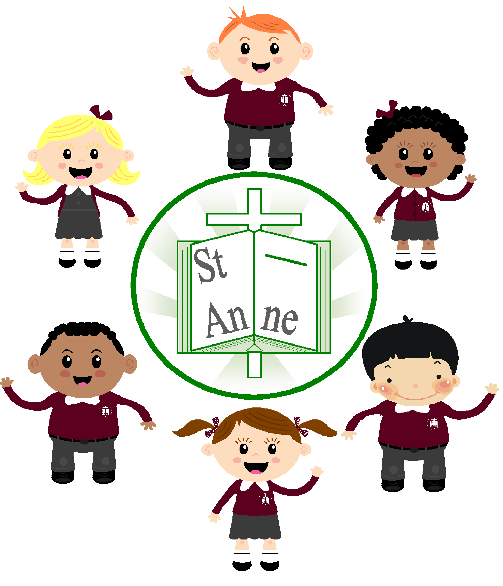

St. Anne (Stanley) C of E School
St. Anne (Stanley) C of E School
Art and Design Policy
A Baseline for Achieving Excellence in Art and Design

January 2016
St. Anne (Stanley) C of E School
Art and Design Policy
A Baseline for Achieving Excellence in Art and Design

January 2016
St. Anne (Stanley) C of E School
Art and Design Policy
A Baseline for Achieving Excellence in Art and Design

January 2016
St. Anne (Stanley) C of E School
Art and Design Policy
A Baseline for Achieving Excellence in Art and Design

January 2016
St. Anne (Stanley) C of E School
Art and Design Policy
A Baseline for Achieving Excellence in Art and Design

January 2016
EYFS Policy
A Baseline for Achieving Excellence

June 2022

St
An

ne

St. Anne (Stanley) C of E School

EYFS POLICY

- Intent

Curriculum Vision:

At St Anne’s we believe every child deserves the best possible start in life. A child’s experiences between birth and age 5 have a major impact on their future life chances. Together with parents and the local community, our aim is to provide the foundation children need to make the most of their abilities and talents no matter what their starting points. We strive to enable all children to reach their full potential as they progress through our school. To become successful in life is our goal - the journey begins in the EYFS.
The implementation of this policy is the responsibility of all teaching staff.

Aims Of Subject:
The aims of the EYFS curriculum at St. Anne (Stanley) are:

- To support all children to become independent and collaborative learners. We will provide a broad and balanced curriculum that will enable each child to develop personally, socially, emotionally, spiritually, physically, creatively and intellectually to their full potential.
- To develop self-regulation skills and executive function in all children, key for successful learning.
- To provide a happy, safe, stimulating and challenging programme of learning and development for the children to experience as they begin their journey through school.
- To provide a broad, balanced, relevant and creative curriculum that will set in place firm foundations for further learning and development in Key Stage 1 and beyond and enable choice and decision making, fostering independence and self-confidence.
- To use and value what each child can do, assessing their individual needs and helping each child to progress.
- To develop the skills of enquiry, investigation, analysis, evaluation and presentation.

The early-years education we offer our children is based on the following principles:
- It builds on what our children already know and can do, ensuring that no child is excluded or disadvantaged.
- It offers a structure for learning that has a range of starting points, content that matches the needs of young children, and activities that provide opportunities for learning both indoors and outdoors.
- It provides a rich and stimulating environment.
- It acknowledges the importance of a full working partnership with parents and carers.

School values:
Our school values are hope, confidence, friendship, family, understanding and honesty. These underpin our ethos and are embedded across our curriculum. In the EYFS this means:
- We encourage children to ask for help.
- Working in collaboration.
- Celebrating each other’s understanding knowledge and achievements.
- Developing perseverance and resilience.
- Building self-confidence, self-esteem and seeing challenge as a positive.
- Involving families in events and activities

Cultural capital:

The curriculum we offer will enhance the experiences and opportunities available to our children, particularly the most disadvantaged. From accessing our curriculum and interactions with staff within our setting, this will potentially make all the difference. It is our role to ensure that children experience the awe and wonder of the world in which they live through the seven areas of learning found within the EYFS curriculum.
It is known that children who have a grasp of formal language, rather than being restricted to informal language, are at an enormous advantage in the education system. Low-level and limited vocabulary, and poor management of grammar, limits children and negatively impacts their expression of analytical and abstract ideas and arguments. We also know that reading is key to helping us communicate the content, vocabulary and styles of expression that help develop language, one that is well rewarded in school. By broadening children’s horizons and offering experiences that extend and stretch them and allow them to challenge themselves, would benefit them both in the present and future. All our activities, provocations and lines of enquiry are designed to enhance vocabulary, build curiosity and engage children with delight and enthusiasm. Cultural capital is strengthened through the extension of language, and through the introduction of interesting resources which would provoke greater conversations; trips within the local area, to galleries, museums, theatre, art exhibitions, science, shopping and eating – all are activities which can open children’s sense to the world around them.

Howard Gardner sums up cultural capital and cultural entitlement with the phrase that every child has a spark inside him and it’s our responsibility to ignite that spark.

Planning and sequencing:

The EYFS framework sets the statutory standards for the development, learning and care of children from birth to age 5. The framework sets the standards that all early year’s providers must meet to ensure that children learn and develop well and are kept healthy and safe. It promotes teaching and learning to ensure children’s ‘school readiness’ and gives children the broad range of knowledge and skills that provide the right foundation for good future progress through school and life.
The Early Years Foundation Stage will use the objectives set out in each Area of Learning (Personal, Social and Emotional Development, Communication & Language, Physical Development, Literacy, Maths, Understanding the World and Expressive Arts & Design).
Four principles shape practice in early year’s settings. These are:
• every child is a unique child, who is constantly learning and can be resilient, capable, confident and self-assured
• children learn to be strong and independent through positive relationships
• children learn and develop well in enabling environments, in which their experiences respond to their individual needs and there is a strong partnership between practitioners and parents and/or carers
• children develop and learn in different ways (see “the characteristics of effective teaching and learning” at paragraph 1.15 Statutory Framework for the EYFS) and at different rates.
The framework covers the education and care of all children in early year’s provision, including children with special educational needs and disabilities.
Within the seven areas of learning and development are three areas which are particularly crucial for igniting children’s curiosity and enthusiasm for learning, and for building their capacity to learn, form relationships and thrive. These three areas, the prime areas, are:
• communication and language (this underpins all seven areas of learning and development. Interactions from an early age form the foundations for language and cognitive development. Frequent, quality conversations in a language rich environment is crucial. Reading frequently to children and engaging them actively and then giving opportunities to use and embed new words will give children the opportunity to thrive)
• physical development (vital in children’s all-round development, enabling them to pursue happy, healthy and active lives)
• personal, social and emotional development (crucial for children to lead healthy and happy lives and is fundamental to their cognitive development)
The specific areas are:
• literacy (deemed crucial for children to develop a life-long love of reading, reading consists of language comprehension and word reading, writing involves transcription and composition)
• mathematics (developing a strong grounding in number is essential so that all children develop the required building blocks to succeed mathematically, spatial reasoning skills are also to be developed and positive attitudes and interests in maths)
• understanding the world (guiding children to make sense of their physical world and their community)
• expressive arts and design (developing children’s artistic and cultural awareness supports their imagination and creativity)
Planning is vital to ensure that children's learning is effective and that they are making the required progress towards the early learning goals (at the end of Reception).
Ensuring planning, observation and assessment techniques are as streamlined as possible, while ensuring all areas of the EYFS are covered, is vital.
By supporting the children’s development by following their interests and providing a broad, balanced and stimulating curriculum is crucial. A good balance between child-initiated and adult-led activities is provided, ensuring our ethos of ‘learning through play’ is always maintained. At various times in our daily routine staff are able to have dedicated quiet time with the children in focus groups to discuss interests and assess learning needs.
Planning in the early years is about meeting young children’s needs so that they can play and learn happily in ways which will help them develop skills and knowledge across the Prime and Specific areas of learning in the EYFS. Between long term planning for trips which will take place over the year and the experiences that are planned for children on a daily and weekly basis are the medium-term plans that are made to ensure that over six weeks or a half term certain areas of learning are addressed. All planning is flexible and used as a guide rather than followed slavishly bearing in mind children’s interests will vary. The most important planning that is done is the short-term daily/weekly planning that arises from discussions with the children and their parents and is based around their current interests.

Progression in play reflects the observation and assessment of children’s knowledge, skills and attitudes in order to provide developmentally appropriate experiences. Children come to us already as skilled learners. Through our observations, assessment and professional judgement we gain valuable insights into how each one learns best. This information informs our planning to meet the needs of each individual child. Progression in play comes about as a result of a real understanding of the interests, needs and experiences of the child. As staff, we need to understand that there must be a progression in the provision of activities to meet the developmental needs of children.

2. IMPLEMENTATION

At St. Anne (Stanley) the whole of the curriculum will be taught by following the Early Years Foundation Stage (EYFS) which sets standards for the learning, development and care of children from birth to 5 years old.

High quality teaching and learning:

Effective learning builds and extends upon prior learning and following children’s interests. Effective planning and teaching is informed by observations of the children to ensure we follow their current interests, as well as identifying areas outside of their experience that will ignite their curiosity and enthusiasm. In this way enhancements to our Continuous Provision are identified and added as appropriate.

Play based learning and teaching is paramount and children direct their own learning from a range of open-ended opportunities provided by staff. Staff will enhance play and extend as needed to challenge and support individual learning for all children.

At St Anne’s we understand that children develop and learn in different ways and at different rates. We are committed to applying the EYFS framework in our setting to ensure it covers the education and care of all children in our provision, including children with SEND.

Play is used as an essential part of children’s development, building their confidence as they learn to explore, to think about problems, and relate to others.

Teaching in the EYFS is focused on improving children’s ‘school readiness’, guiding the development of children’s cognitive, behavioural, physical and emotional capabilities, so that children can take full advantage of the learning opportunities available to them in school.

At St Anne’s we support children in using the three characteristics of effective teaching and learning; playing and exploring, active learning, creating and thinking critically.

Opportunities to develop subject specific literacy – oracy and vocabulary:

Many of our children begin with delayed communication and language. Our aim is to provide a rich and varied environment that supports children’s language learning. Time is invested early on reading aloud, singing, reciting nursery rhymes and talking to children as much as possible as well as listening to what they have to tell us. Language and literacy skills have a huge impact on a child’s outcomes. Research shows that there is a significant gap between children with good and poor language skills when they begin school. It is a vital part of our role in the EYFS that language skills are promoted to address this gap. There is a focus on how much language children hear during their early development and in turn how much vocabulary they can use and understand. Repetition is key: the more a child hears a word the more likely they are to learn it. Variety of language that children experience is also crucial.
Early knowledge about sounds and meanings of words affects how we learn to read. The quantity of language a child experiences before learning to read has a substantial and long-term effect on their ability to learn to read. Learning to read piggy-backs on oral vocabulary. At St Anne’s we are aware that greater language experiences improve language skills. Shared book reading expands vocabulary exposure, talking about events in the past or future introduces words that are not so relevant to the present.
We ensure that vocabulary linked to Areas of Learning within the EYFS curriculum are displayed within the environment for staff to model and use with the children. As a staff we model good speaking and listening.

Progress – knowing more and remembering more:

To ensure that progress is made for all children the staff consistently build on the children’s prior learning to deepen their understanding and build confidence in their own ability. Home visits and Nursery visits (if appropriate) are made prior to the children beginning in our setting to gain an insight into a child’s starting points through discussions with parents/carers.
Development Matters (Non-statutory curriculum guidance for the early years foundation stage September 2020 Revised July 2021) guides our professional judgement on how children learn and develop. This guidance helps us to meet the requirements of the Statutory Framework for the Early Years Foundation Stage (March 2021). Development Matters sets out the pathways of children’s development in broad ages and stages to help assess each child’s level of development. The guidance also helps to check that children are secure in all the earlier steps of learning before looking at their “age band”. Depth in learning is a priority rather than moving too quickly from one band to the next. A child’s learning is thought to be secure if they show it consistently and in a range of different contexts. Observation checkpoints are used to notice if a child is at risk of falling behind in their development. By taking action quickly the extra help can be given. Parents will be notified through a sensitive dialogue and suggestions made to support the home learning environment. Health colleagues will be invited to offer extra support.
Children are assessed on-entry then tracked throughout their time in EYFS to ensure progress is taking place within all 7 Areas of Learning as well as in their characteristics of effective learning.
The termly progress summary (GLD Tracker) identifies next steps for individuals, groups of children and for the cohort. Gaps in learning are identified and addressed.
Parents are involved in understanding and supporting children’s progress.
Moderation takes place internally and externally to validate judgements made.
Progress information is used to support transitions as children move into Reception or Year 1.

Assessment:

The purpose of monitoring and evaluation activities is to raise the overall quality of teaching and levels of pupil attainment. The EYFS Lead and the Head teacher will monitor the quality of teaching and learning within the EYFS through Learning Journey and book scrutiny, lesson observations and learning walks.
Through careful ongoing observation and assessment, including information provided by parents (on-entry and ongoing) and other settings (when children join our school), children’s development stages are assessed. As far as possible, assessment of children’s capabilities is done through observation of child initiated activities i.e. what a child can do independently without support. These observations are used to assess how children are achieving in line with age related expectations.
NFER assessments (Literacy and Maths) are used as a baseline on-entry to Reception alongside staff making and recording their own judgements across all seven areas of learning. At the end of the EYFS a child’s achievements related to the seven areas of learning are recorded within the Early Years Foundation Stage Profile (emerging, expected or exceeding standard attained).
The primary uses of EYFSP data is to: inform the parents about their child’s development against the ELG’s and the characteristics of effective learning; support a smooth transition to KS1; help Year 1 teachers plan a curriculum that will meet the needs of all children.

Learning environment:

At St Anne’s we know that children learn and develop well in enabling environments. Our aim is to create such an environment, both physical and emotional, in which children’s experiences respond to their individual needs and there is a strong partnership between practitioners and parents/carers.

An enabling environment is one that provides support for children to take risks and explore; we encourage our children to learn to do this responsibly, by observing, recognising what children are aiming to do, standing back to allow them to figure things out for themselves and when necessary, supporting verbally or with resources.

We strive to create an attractive and stimulating learning environment where children feel confident, secure and challenged.

Children’s work and achievements will be celebrated through displays and within their Learning Journey books and work books.

Reading:

Enjoying books and reading stories from a very early age is crucial in the development of a positive attitude to reading for all children especially for those from a disadvantaged background. It helps with their ability to understand words, use their imagination and develop their speech, as well as being something they really enjoy.
Staff and parents play a huge part in the development of reading skills in young children. The more children experience books and print around them within their environment the more they will gain the interest and passion for words. Reading helps to develop spelling, listening, writing, literacy and social skills.
Young children need to be able to experience books; understand and enjoy stories, rhymes and songs and listen and respond to them with curiosity and enjoyment.
The ability to read is embedded throughout the curriculum at St Anne’s and the children are given many opportunities to develop their understanding through a rich and diverse programme of learning. Children are taught to read at an early age and they are given the opportunity to develop their reading skills in all subject areas.
To develop a love of books and reading is our aim in EYFS.

Inclusion:

Staff at St. Anne’s are aware that every child, whatever their diverse learning needs, must be given the opportunity to achieve their full potential. We will respond to the needs of children whatever their ability. We will ensure that we provide learning opportunities that enable all children to make progress by setting suitable learning challenges and responding to each child’s needs through differentiation of task, resources and outcome.
We are committed to:
• Opposing all forms of discrimination – individual and institutional, direct and indirect.
• Challenging all forms of discrimination about different groups in society.
• Translating good equal opportunities principles into all our policies and practice.
• The need to allow pupils to be able to work in their preferred learning styles for some of the time.
• Using materials for teaching which avoid stereo-typing, and bias, towards different groups in society.
• Maintaining and developing an inclusive culture where every individual feels valued and aspires to succeed.

Staff have high expectations for all children but we also ensure that able, gifted and talented pupils have opportunities provided that develop and apply their particular capabilities. We will expect:
- Teachers to provide teaching and learning experiences that encourage pupils to think creatively, explore and develop ideas, and try different approaches. Pupils should be encouraged to set their own questions, offer ideas, suggest solutions or explanations, and reflect on what they have heard, seen or done in order to clarify their thoughts.

- Greater independence in working.

- Encouragement of children to communicate their understanding in a variety of ways.

- Provision of opportunities within the EYFS curriculum for pupils to develop their skills in other areas, such as intrapersonal skills (opportunities to use initiative), and interpersonal skills (leadership and group membership). These opportunities also relate to the key skills of working with others and improving own learning and performance.

We ensure that teaching and learning is accessible for all pupils including those with EAL. Teaching good listening and speaking skills is key for all children-focussing on these areas and positively encouraging all attempts will have great benefits.
A child’s home language is integral to a child’s cultural and individual identity, and should be encouraged to be used and developed at home. Home language skills can easily be transferred to new languages and therefore will help to support a child’s understanding of language. Working closely with the child’s parents/carers to ensure that the home language is not discarded will be key to ensuring for a partnership that successfully supports a child with EAL.
When a child is starting to learn English, it is very normal for them to go through a silent phase (which can last up to 6 months). Staff are aware of the importance of this phase due to the child absorbing what they are learning and building on their understanding all in readiness for speaking. Staff still encourage and talk to the child in the knowledge that understanding comes first, and when a child feels ready, they will speak.

SMSC/British Values:

At St Anne’s we realise the importance of preparing children for “life in Britain”. By promoting the spiritual, moral, social and cultural development of every child we actively promote the fundamental British values of:
- Democracy
- The rule of law
- Individual liberty
- Mutual respect for and tolerance of those with different faiths and beliefs

The EYFS curriculum enables children to develop their self-knowledge, self-esteem and self-confidence. We encourage children to develop a sense of responsibility and distinguish right from wrong beginning from their first day, no matter what their age. Children are encouraged to contribute positively to the lives of those living and working in the locality of the school thus developing a sense of community and respect. An appreciation of and respect for their own and other cultures and faiths is fostered. Crucially, all pupils within the school have a voice that is listened to.

Enrichment:

After-school clubs are available to children in Reception on a half-termly rota. The focus is “finger-gym”, “communication and language” and “PSE development” and includes dough-disco, lego club and cooking activities. Small groups of children are selected as those who would benefit the most from the activities but it is available for all children to attend over the year.

Visits are made and visitors invited to school on a regular basis to provide enrichment to the EYFS curriculum and also to enhance children’s interests.

Homework:

This takes the form of activities which supports work undertaken in class and also which supports areas of learning across the EYFS. Library books are taken home on a daily basis and books taken from the school reading scheme are taken home when the child is ready to begin “formal” reading.

3. Impact: what will our children look like?

Resilient, inquisitive, confident, ambitious, challenged, empathetic, compassionate, respectful, reflective, thriving, articulate and knowledgeable are all words which describe our aims for children leaving our school

This brings us back to the vision stated at the beginning of this policy:

“To become successful in life is our goal - the journey begins in the EYFS.”

Christine Riley
EYFS Lead

Date of Review June 2022
Date of next review June 2023

