Tribal Group
Kings Orchard
One Queen Street
Bristol
BS2 0HQ

19 July 2022

QUALITY MARK

Dear Parents and Carers,

I am delighted that your child’s school has recently been awarded a Quality Mark Award.

This national accreditation is awarded to schools which meet the Quality Mark Standard and will last for three years, after which a renewal assessment is required.

The Quality Mark promotes, supports and celebrates progress and improvements made by a school in English and mathematics. Without these ‘basic skills’ of good communication, English and mathematical skills, individuals are disadvantaged throughout their lives – as learners, in the workplace and as parents, consumers and citizens and so they form the ‘bedrock’ of a good education.

To achieve a Quality Mark, schools have to undergo an assessment, carried out by an external accredited assessor, against the 10 ‘Elements’ of the Quality Mark framework. These cover key aspects of the school’s improvement agenda, including the identification and analysis of the school’s needs; strategic planning; target setting for improvement; intervention and support for pupils under-achieving or under-attaining; provision of quality in both teaching and in resources; staff development; and active engagement with families. Effective monitoring and evaluation are also required - particularly to achieve renewal when continuing development by the school and evidence of impact of actions must be demonstrated.

I hope you will share in the pride of the school and its pupils in achieving this award.

Yours faithfully,
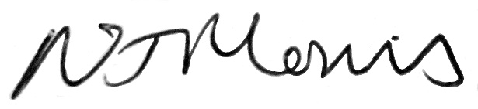
Nicola Morris, Quality Mark National Director

