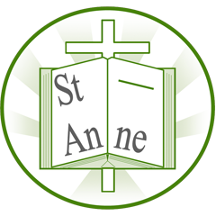
St Anne (Stanley) Reading Newsletter
Summer Term 1

Welcome to our reading newsletter
In this letter, we aim to detail the books that we are reading and learning about in class, as well as exploring some new books that are available for you to buy.
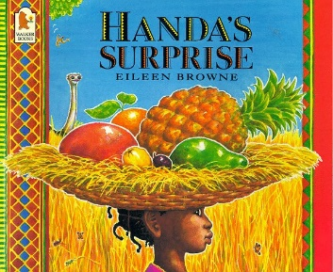
Nursery
In this picture book classic, a delightful surprise colourfully unfolds when a little girl called Handa puts seven delicious fruits in a basket to take to her friend.
2-4yrs

Reception
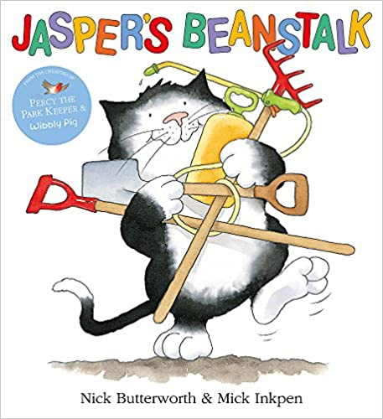
A snuggly classic by two best-loved picture book creators: a story of kittens, nature and learning how things grow! On Monday, Jasper plants a bean. He waits all week for it to grow into a beanstalk. He waters it, checks on it and cares for it. But now he’s getting bored.
Just how long must Jasper wait before he can start looking for giants?
3-6yrs

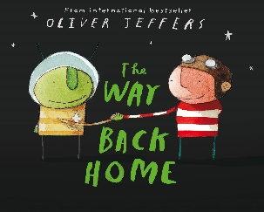
Year 1
Shining star Oliver Jeffers returns with a star-spangled space adventure. One day a little boy finds an aeroplane in his cupboard. Up, up and away he flies, high into the sky. He whizzes past clouds, stars and planets – until suddenly he runs out of petrol! Miles from earth, he crashes into the moon. Just as he is getting cold and lonely, a friendly Martian appears, also with a broken aircraft. Together they come up with a super rescue plan. But will it work? Will the boy find his way back home to earth – and will the two friends meet again? A rich and unusual story of friendship and exploration, shimmering with colour and invention.
3-4yrs
Year 2
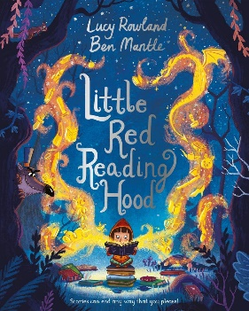
Little Red Reading Hood loves reading books and making up stories of her own.
When she meets a cunning wolf while on her way to the library, he convinces her to stray
from the path and read for a little while. But hasn’t she read this in a story before?
Perhaps it’s time she came up with a new ending . . .This is a contemporary and fun take on the classic fairy tale, Little Red Riding Hood, created by an incredible picture book partnership. With a playful rhyming story by Lucy Rowland and Ben Mantle's entertaining illustrations, Little Red Reading Hood will inspire children, and adults, about the magic of books and reading.
3-7yrs
Year 3
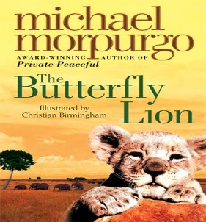
Deep in the burning African veld, a young boy rescues an orphaned white lion cub. But when the friends are torn apart and the lion is sold to a circus, how will their story end? This modern classic from Michael Morpurgo sweeps from a British boarding school to the African wilds, and from the First World War to the present day. It is a striking and heart-warming story of friendship against all the odds, which paints a vivid landscape in the mind.
7-8yrs
Year 4
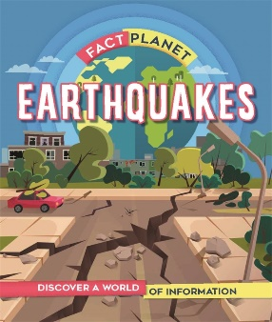
Find out about earthquakes and learn how they form, where they are most likely to happen and how scientists study them, through diagrams and case studies.
Fact Planet is a lively, information-filled geography series, packed full of colourful illustrations, clear explanations and fun quizzes to test your knowledge. The eye-catching flat illustrations combined with occasional photos bring geography and environmental issues to life.
7+yrs

Year 5
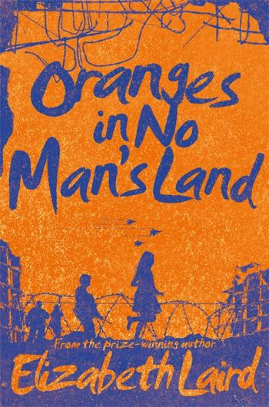
Oranges in No Man's Land brings Elizabeth Laird's emotional and gripping adventure to her next generation of fans.
Since her father left Lebanon to find work and her mother tragically died in a shell attack, ten-year-old Ayesha has been living in the bomb-ravaged city of Beirut with her granny and her two younger brothers. The city has been torn in half by civil war and a desolate, dangerous no man's land divides the two sides. Only militiamen and tanks dare enter this deadly zone, but when Granny falls desperately ill, Ayesha sets off on a terrifying journey to reach a doctor
living in enemy territory.
8-11yrs

Year 6
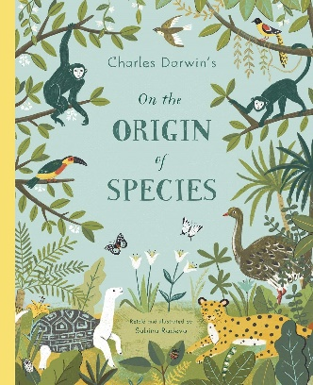
For most of human history, people believed that everything in the world was created at once. But scientists started to challenge that idea and in 1859 Charles Darwin, a naturalist and biologist, wrote a famous book called On the Origin of Species that revolutionised the way that we have understood evolution ever since.
Now molecular biologist and illustrator Sabina Radeva has recreated Darwin's most famous work as a beautifully illustrated book for children and adults alike. The stunning pictures bring the theory of evolution to life for young readers, and anyone who wants to learn about evolution.
Pulling together Darwin's observations from his travels around the world and his ground-breaking explanation of how species form, develop, and change over hundreds of thousands of years, On The Origin of Species is as relevant and important now as it ever was.
9-12yrs

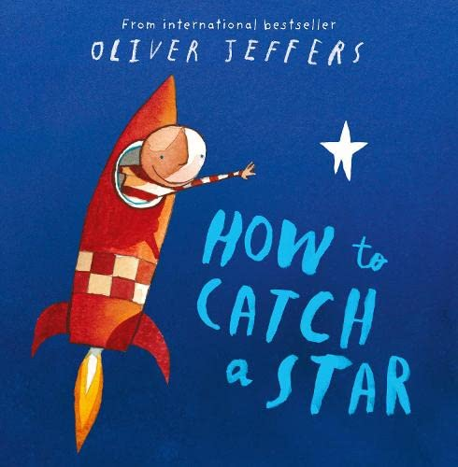
Other books you may enjoy
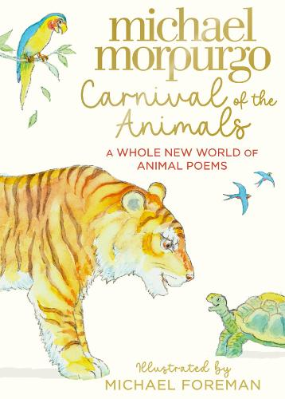
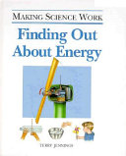
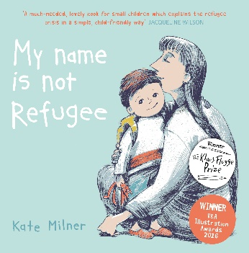
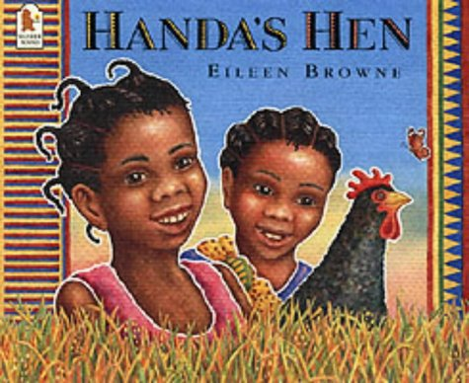
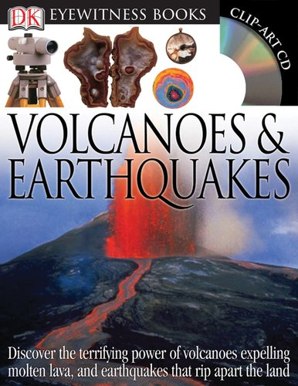
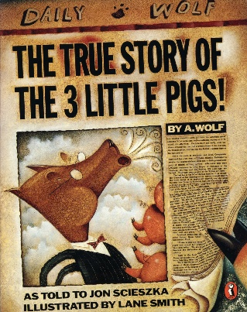
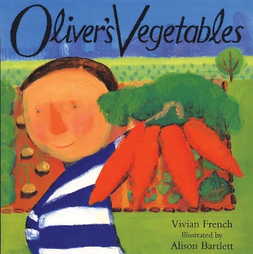

Books of the month (www.booksfortopics.com)
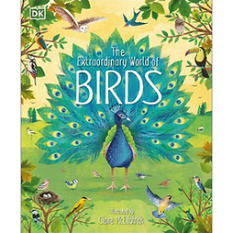
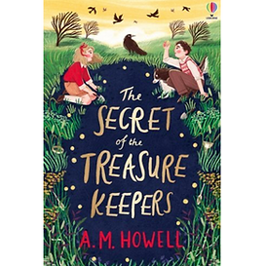
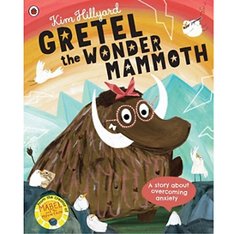
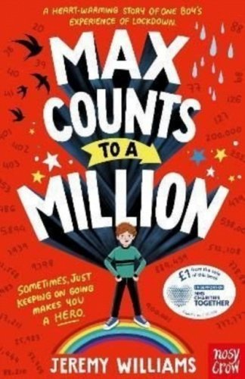
Suitable for 7+yrs Suitable for 3+yrs Suitable for 9+yrs Suitable for 7+yrs

At St Anne (Stanley) we want to actively encourage reading for pleasure at home and in school. Children need support to develop the habit and love of reading and we do this through reading aloud, giving time to read and book talk.

‘So ‘just relax and read’. Time and space to hear stories and to read and talk informally about what you’re reading makes a difference to children’s pleasure in reading.’

If you have any recommendations for books that you think your friends and family would enjoy, please come and let me know and I will try and add them to our newsletter

Miss Sargent

