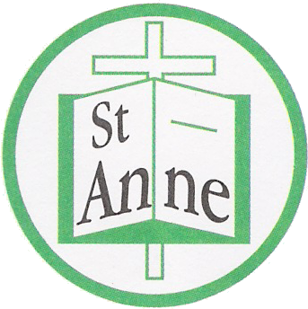

Date: 09/03/2022

Dear Parent or Carer,

We have been made aware that members of our school community attached to YEAR GROUP 2KB have tested positive for COVID 19.

There are things you can do to help reduce the risk of you and anyone you live with getting ill with COVID-19.

Eligible household members should do a rapid test twice a week (every 3 to 4 days) to check if you have the virus. If people test positive and self-isolate, it helps stop the virus spreading. Even if you’re vaccinated, there’s still a chance you can pass COVID-19 on, so you should keep getting tested regularly. To access home test kits, please see the following link below: https://www.gov.uk/order-coronavirus-rapid-lateral-flow-tests
How to stop COVID-19 spreading
- wash your hands with soap and water often – do this for at least 20 seconds
- use hand sanitiser gel if soap and water are not available
- wash your hands as soon as you get home
- cover your mouth and nose with a tissue or your sleeve (not your hands) when you cough or sneeze
- put used tissues in the bin immediately and wash your hands afterwards

Further Information
Further information is available at https://www.nhs.uk/conditions/coronavirus-covid-19/

Symptoms of COVID 19

If your child does develop symptoms of COVID 19, self isolate and book a PCR test. You can seek advice from NHS 111 at https://www.nhs.uk/conditions/coronavirus-covid-19/check-if-you-have-coronavirus-symptoms/or by phoning 119.

Yours sincerely,

Mrs J. Simons
Headteacher

