St Anne (Stanley) CE Primary & Nursery School
Prescot Road
Liverpool
L13 3BT
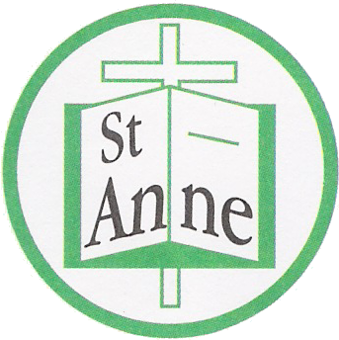
Tel : 0151 228 1506

Email: Stanley-ao@st-annesstanley.liverpool.sch.uk

19th November, 2021

Dear Parents and Carers,

We have had a number of isolated cases of Covid 19 recently and wish to reassure you that we remain vigilant in our determination to reduce the spread of infection. Measures remain in school to help protect the whole school community, we continue to have extra cleaning regimes throughout the day with fogging of classrooms after school on a rota basis. Regular hand washing and staggered times for lunch, play and hall remain part of the school day. We also encourage adults to wear face masks within common areas such as the hall, corridors and playgrounds. Adequate ventilation is key to ensuring that everyone remains safe and well and so windows are opened frequently throughout the school day.

Due to current measures Parents/Carers evenings this term will be through School Cloud and will take place during the week beginning 29th November. As, with previous meetings you will be given an allocated time to discuss your child’s learning with the class teacher. Please ensure that you are on time for your meeting as the sessions are automatically timed and will move on to the next visitor once time is up. If you have any difficulty accessing these meetings or wish to arrange a telephone call instead, please contact your child’s class teacher to arrange this.

We intend to provide lots of exciting opportunities this academic year, as we are keen for our children to enjoy many memorable and exciting learning events. Obviously, this will depend on current government advice as we continue to keep our school community safe. We want our children to have the best possible time in our school and will do everything we can to ensure that they enjoy their learning and the many planned events ahead.

Please see the attached dates for your child’s class diary (which will also be posted on class pages). I am sure this will help in preparing for future planned events. This year we will have year group assemblies in St. Anne’s Church, rather than in our school hall. Whilst in church, we ask that everyone wears a face mask and continue to use the one-way system in place.

As a church school, we have especially missed the Christmas Nativities and Carol Concerts, so we are really excited to enjoy these special times once again. We will however, do this slightly differently with the children performing twice in one day so that our families can enjoy watching safely. Each year group will have a set time and day, but we have to restrict attendance to two seats per family.

The children will also enjoy a visit to our Christmas Grotto and Disco within their year groups along with taking part in class parties and the school raffle.

We are extremely proud to have such a lovely school community and wish to thank you all for continuing to work together to help our children thrive.

Kindest wishes to you all.

Julie Simons
Headteacher

