To all Principles and Head Teachers,

I am writing to raise concern regarding the current upward trend in the use of both personally owned and hired E-Scooters here in Merseyside.
Liverpool is currently taking part in a Liverpool City Region led pilot with VOI scooters, which aims to establish e-scooters in every neighbourhood to help combat the rise in vehicle use on our roads and promote a more eco-friendly mode of transport. These scooters are easily identifiable being orange in colour and displaying a small registration number on the front and back.
Since its inception in September 2020, the VOI pilot scheme has helped to inadvertently promote the wider use of electronic scooters in the city and as a result, we have seen an unprecedented number of personally owned scooters now being used by both children and adults alike on our streets. Many are now being used to ferry children to school, and reports of multiple VOI scooters being parked outside many school entrances with students using these as a form of transport, sometimes illegally dependant on their age and the absence of a substantial drivers’ licence.
With the above in mind, we feel there is a need to promote a better understanding of laws and legislation which governs the use of these new scooters despite numerous social media and news reports. My intention in sending you this letter is to seek your support to educate your students and parents through your assemblies and newsletters etc. This I hope will have two separate outcomes, firstly the roads will become safer for all users especially children and secondly we will reduce the number of accidents being reported to our local hospitals who are also seeing a rise in incidents being recorded caused by e-scooters alone.
- VOI Scooters.
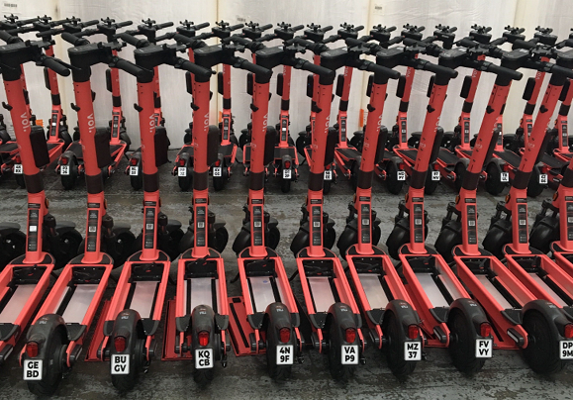
• Introduced in September 2020 and certified by the Department for transport
• All Riders must hold a valid UK Provisional or full driving license
• All riders MUST BE 18+ years old
- The use of these scooters utilising another person’s license will result in prosecution for both the rider and the license holder.
- As scooters are deemed as a motor vehicle ANY prosecution on these scooters will have a significant impact on gaining a driving license and or insurance in the coming years.
- Due to the rise in use by underage school children, Voi and Merseyside Police will be targeting users in order to stop this action which may lead to prosecution and or fines

- Private Scooters

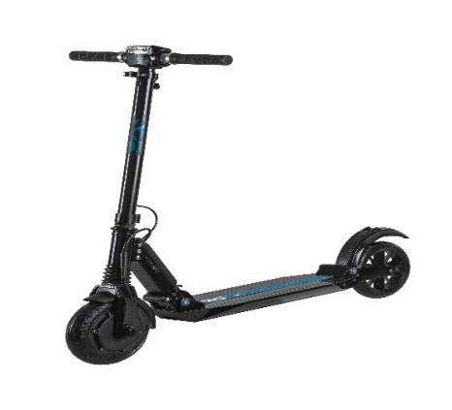
- These can be various colours
- Do not display registration numbers
- Available from UK and oversees manufactures
- Scooters can be adapted and modified to travel father than the 15.5 Mph limit placed on them
- It is against the law to ride an e-scooter anywhere other than on private land and only then, with the express permission of the landowner
- If you are found to be riding one in public, you could face having your scooter seized, a fine, or even points on your driving licence
- Due to E scooters being classified as “powered transporters”, they are covered by the same legislation as motor vehicles and therefore would need to meet the same standards under the Road traffic Act 1988 to be legalised in public such as being insured, registered with the DVLA and taxed.
- If you are found to be drink or drug riding you will face the same court process as you would in a car and you will be arrested.
I’m sure you would agree that the safety of all students is paramount as we now head into a busy summer period away from school and I hope that given this small piece of information you are able to make both students and parents think twice before riding any of the above scooters types.
If required further information can be found an all relevant departments below:
- E-Scooter legislation
- VOI
- Liverpool Echo

We are working very closely with a number of partner agencies concerning the use of E scooters, and this issue is not just specific to Merseyside however changes to law and legislation take time and given the pilot schemes are being ran in various cities throughout the UK until May 2022, it is very unlikely we will see any legislative changes being made until the outcome of these pilots. Therefore until then we have to enforce the laws that are in place and with 273 scooters being seized in the last three months, we will continue to try and curb this ever growing issue.
Kind Regards
Carl McNulty
Insp Matrix Op Support Roads Policing
MTRX RPU Operations
Direct Line Tel: +441517771249
Email: Carl.R.McNulty@merseyside.police.uk

