St Anne (Stanley) CE Primary & Nursery School
Prescot Road
Liverpool
L13 3BT
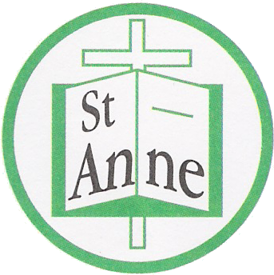

Tel : 0151 228 1506

Email: Stanley-ao@st-annesstanley.liverpool.sch.uk
17th July 2021

Dear Parent or Carer,
We have been advised by Public Health England that there is a confirmed case of COVID-19 within our school community.
I would like to take time to reassure you that we have taken all necessary actions since hearing this information to keep all children at our school as safe as possible. The children and staff in the bubble are now self-isolating for 10 days and the school has been cleaned appropriately.
Currently, the most common strain of virus in the UK is called the Delta variant and we have seen a steep rise in COVID-19 cases recently. Evidence suggests the Delta variant spreads more easily than previous strains. It is important that we are vigilant and follow public health messages to stop the spread of the virus

How to stop COVID-19 spreading
How to stop coronavirus (COVID-19) spreading
There are things you can do to help reduce the risk of you and anyone you live with getting ill with coronavirus (COVID-19):
- Hands: wash your hands with soap and water often – do this for at least 20 seconds
- use hand sanitiser gel if soap and water are not available
- wash your hands as soon as you get home
- Face: wear a mask in public places and on public transport; ensure it fits comfortably and covers both your mouth and nose.
- cover your mouth and nose with a tissue or your sleeve (not your hands) when you cough or sneeze
- put used tissues in the bin immediately and wash your hands afterwards
- Space: Where possible keep 2 metres / 6 feet apart from others outside of your family / bubble.
- Ventilate: Where reasonably practicable, doors and windows should remain open to allow fresh air to pass though and reduce the density of COVID-19 particles indoors.
- Vaccination protects against the Delta variant, and both doses are needed for maximum coverage. Public Health are advising that it is therefore important that you get your COVID-19 vaccine as soon as you are offered. This will ensure that further spread is limited quickly and effectively.
- Continue to do asymptomatic lateral flow device testing at home, twice per week (secondary age pupils, and household members of any child in a school bubble). https://www.gov.uk/guidance/coronavirus-covid-19-getting-tested
- We continue to ask that parents and carers wear face coverings when dropping off and picking up children from school.

Further Information
Further information is available at https://www.nhs.uk/conditions/coronavirus-covid-19/

Symptoms of COVID 19
The most common symptoms of coronavirus (COVID-19) are recent onset of:
- new continuous cough and/or
- high temperature and/or
- a loss of, or change in, normal sense of taste or smell (anosmia)
For most people, coronavirus (COVID-19) will be a mild illness.

If your child does develop symptoms, you can seek advice from NHS 111 at https://www.nhs.uk/conditions/coronavirus-covid-19/check-if-you-have-coronavirus-symptoms/or by phoning 119.

Yours sincerely,

Julie Simons
Headteacher

