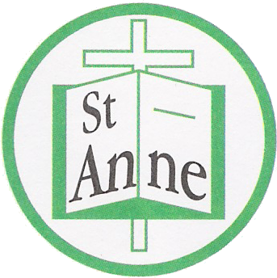
St Anne (Stanley) C of E School
Prescot Road
Liverpool
L13 3BT

Tel : 0151 228 1506
Fax : 0151 228 8581

Email: Stanley-ao@st-annesstanley.liverpool.sch.uk

Tuesday 8th June 2021

FOR PARENTS/CARERS OF DIRECT CLOSE CONTACTS OF COVID 19 at ST. Anne’s (Stanley) C of E Primary School – Class REC M

Advice for Child to Self-Isolate for 10 Days

Dear Parent or Carer,

We have been advised by Public Health England that there has been a confirmed case of COVID-19 within the school.

We have followed the national guidance and have identified that your child has been in close contact with the affected individual. In line with the national guidance, we recommend that your child now remains at home and self-isolates until 18th June.

We are asking you to do this to reduce the further spread of COVID 19 to others in the community.

If your child is well at the end of the 10 days period of self-isolation, then they can return to usual activities. A negative test does not mean that your child can return to school earlier than 10 days.

Other members of your household can continue normal activities provided your child does not develop symptoms within the 14 day self-isolation period.

Please see the link to the PHE Staying at Home Guidance
https://www.gov.uk/government/publications/covid-19-stay-at-home-guidance/stay-at-home-guidance-for-households-with-possible-coronavirus-covid-19-infection

What to do if your child develops symptoms of COVID 19
If your child develops symptoms of COVID-19, they should remain at home for at least 10 days from the date when their symptoms appeared as advised in https://www.gov.uk/government/publications/covid-19-stay-at-home-guidance

You should arrange for testing for your child via https://www.gov.uk/guidance/coronavirus-covid-19-getting-tested or 111.nhs.uk or primary care

All other household members who remain well must stay at home and not leave the house for 10 days.

The 10-day period starts from the day when the first person in the house became ill.

Household members should not go to work, school or public areas and exercise should be taken within the home.

Household members staying at home for 10 days will greatly reduce the overall amount of infection the household could pass on to others in the community

If you are able to, move any vulnerable individuals (such as the elderly and those with underlying health conditions) out of your home, to stay with friends or family for the duration of the home isolation period

Symptoms of COVID 19
The most common symptoms of coronavirus (COVID-19) are recent onset of:
- new continuous cough and/or
- high temperature and/or
- a loss of, or change in, normal sense of taste or smell (anosmia)
For most people, coronavirus (COVID-19) will be a mild illness.

If your child does develop symptoms, you can seek advice from NHS 111 at https://www.nhs.uk/conditions/coronavirus-covid-19/check-if-you-have-coronavirus-symptoms/or by phoning 119.

How to stop COVID-19 spreading
There are things you can do to help reduce the risk of you and anyone you live with getting ill with COVID-19
- wash your hands with soap and water often – do this for at least 20 seconds
- use hand sanitiser gel if soap and water are not available
- wash your hands as soon as you get home
- cover your mouth and nose with a tissue or your sleeve (not your hands) when you cough or sneeze
- put used tissues in the bin immediately and wash your hands afterwards

Further Information
Further information is available at https://www.nhs.uk/conditions/coronavirus-covid-19/
Yours sincerely,

Julie Simons
Headteacher

