St Anne (Stanley) CE Primary & Nursery School
Prescot Road
Liverpool
L13 3BT
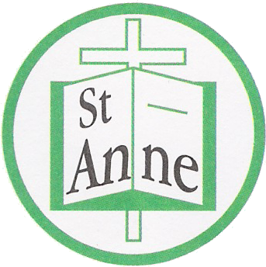

Tel : 0151 228 1506
Email: Stanley-ao@st-annesstanley.liverpool.sch.uk

23rd June, 2021

Dear Parents,

We would like to thank you all for your understanding and commitment throughout the year. The pandemic has been a challenging period for us all, and we really value your continued support, during these uncertain times.

The lovely messages of appreciation and support from many of you have really meant a lot, we are lucky to have such a wonderful school community.

Unfortunately, following half-term there has been a sudden increase in the number of positive cases in schools across the Liverpool City Region. We have had three class bubbles required to isolate (one of which has needed to isolate twice in recent weeks). I would like reassure you that we continue to do everything possible to keep our children, staff and families safe. Our Health and Safety provider can give no further recommendations to what is already in place on our risk assessment (this can be viewed on our school website). The school receives regular updates from the Local City Council and immediately adheres to both local and national guidance.

We continue to have a one-way system in place, pupils remain in individual class bubbles, all desks remain in forward facing rows, we have extra cleaning throughout each day and we use a fogging machine at the end of the school day. Both staff and pupils regularly wash their hands, maintain social distancing, keep to staggered times throughout the school day. Staff wear visors and/or masks - on the school grounds and especially within any communal areas. They are all keen to do their very best to keep everyone safe and are being tested twice weekly to also help reduce the risk of transmission within school.

To further support our school community, especially with the new Delta variant which is very transmissible – can we please ask that you do not send your child into school if they are unwell. Recently, we have been informed by parents that children have tested positive with different symptoms such as a headache/sore-throat/stomach upset rather than the known symptoms of high temperature, loss of taste or smell or a new persistent cough. It is required that PCR tests are taken if an individual has symptoms as these tests are able to identify Covid-19 more reliably than lateral flow testing (LFT).

We urge all parents and carers to continue to wear a face covering on the school grounds - this really does help reduce the risk of transmission in school along with maintaining social distancing on the school yards. We also ask that all parents leave the yard as soon as their child has joined their class line and that people do not congregate around the school gate. Together, we can help keep our school community safe.

In recent years, we have always looked forward to end of term activities such as sports days, concerts, visits – unfortunately due to restrictions we are unable to provide the same experiences this year. Instead, we have arranged lots of wonderful experiences in school such as Bread Making, Yoga Bears, Archery, Judo, Balance Bikes, Skoot School, Bikeability, Beth Tweddle Gymnastics, POWER Programme, Young Leader Training, Altru Drama, Music Club, Road Safety Workshops, First Aid Workshops and many more.

We intend to provide lots of exciting opportunities in the weeks ahead, such as a school barbecue, class parties, sports afternoons, themed lunches, film events and other memorable events that the children will help decide upon. Obviously, these will all happen within each class bubble as we continue to keep our school community safe. We want our children to have the best possible time in our school and we will do everything we can to ensure that they enjoy their learning and the end of year activities.

We are extremely proud to have such a lovely school community and thank you all for continuing to work together to help our children thrive.

Kindest wishes

Julie Simons
Headteacher

