St Anne (Stanley) CE Primary & Nursery School
Prescot Road
Liverpool
L13 3BT
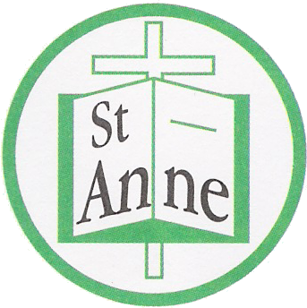

Tel : 0151 228 1506
Fax : 0151 228 8581

Email: Stanley-ao@st-annesstanley.liverpool.sch.uk

26th February, 2021
Dear Parents / Carers,
As you are all aware, the government have decided that ALL primary school children will be returning to school from Monday 8th March, 2021.
We are very pleased to be welcoming back all our children and are looking forward to seeing everyone together again soon. The past twelve months have been a roller coaster of emotions for the children, yourselves, your family and our staff. We are very keen to try and get back to some normality and are planning so that your children can enjoy school and recover their lost education.
We will continue to have our staggered school day with different start and finish times – a copy of this is attached. Each class will continue to work in a class bubble with their own lunch and play times throughout the day. Their allocated times for P.E. have not changed and children are to wear their P.E. kit on these days. As the majority of P.E. lessons will be outside, children should wear their tracksuit bottoms until the warmer weather when they can wear shorts instead if they prefer.
All children can continue to have a hot or cold lunch – though some year groups will continue to enjoy their lunch within their classroom. Our school lunch menu can be found on the school website. Please continue to pay for both school lunch and breakfast club for the week ahead using our parent mail. We are arranging to take payment for after school club using this system as soon as possible. If your child is entitled to free school meals these will continue to be provided.
Robust risk assessments are in place to ensure the safety of our whole school community – these are reviewed regularly and can be viewed on our school website.
Breakfast Club continues to start at 8.00 am. This is to support children of key workers. If you do not already have a place for your child in Breakfast club but now require a place, please ring the school office and book this in advance of their return.
We have designed a recovery curriculum which will help your child to catch up with any gaps in their learning but will most importantly focus on supporting their emotional wellbeing.
Please can we ask that you continue to consider the safety of our children, families and staff. Face coverings must be worn on our grounds and in our school building. A distance of 2 metres should be maintained – our staggered times will support with this. If you need to speak to a member of staff, we ask that you kindly telephone in the first instance. If a face to face appointment is necessary, this can be arranged through contacting the school office. Please don’t consider our staff rude if they ask that you follow this procedure, we want to ensure that we keep everyone safe and prevent the need for any further school closure.
The children will continue with our safety routines of washing/sanitising their hands, maintaining distance from other bubbles of children and following government safety guidelines. We will do everything possible to keep our precious children and the whole school community safe. If you have any concerns about your child returning to school – please do not hesitate to contact me via the school phone number.
Thank you all for your continued patience and understanding throughout these unprecedented times. We are extremely grateful for all the positive messages of support from so many of you, they really have been very much appreciated.
We look forward to seeing our whole school family back together soon.

Warmest wishes to you all.

Mrs. Julie Simons
Headteacher

