St Anne (Stanley) CE Primary & Nursery School
Prescot Road
Liverpool
L13 3BT
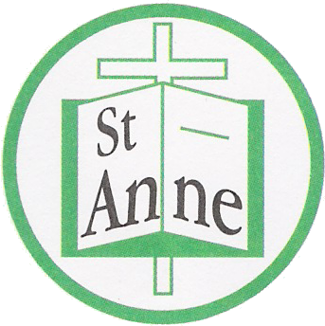

Tel : 0151 228 1506
Fax : 0151 228 8581

Email: Stanley-ao@st-annesstanley.liverpool.sch.uk

26th January, 2021

Dear Parents/Carers,

We hope you are all keeping safe and well during the lockdown.

I would like to take this opportunity to thank all of the children for adjusting to the new on-line learning so positively – whether learning from home or within school. I would also like to thank you, our parents and carers, for all of your understanding and support since the beginning of this term when we had very short notice of the lockdown and the new implications of on line learning. Thank you, especially to all those parents who have sent us messages of support and encouragement throughout this time. These gestures really do go a long way towards keeping up morale!

The staff are working hard to ensure that your child has no lost learning whilst at home and that the curriculum is followed to ensure the children do not fall behind. Whilst, we all appreciate the necessity of the lockdown in order to keep everyone safe, it is vital that we continue to support our children’s education. In order to do this, the staff have worked really hard to provide on-line learning that will enable the children to progress whilst learning at home so they can continue to progress throughout the year.

Please see the attached Remote Education Provision policy which outlines what we are offering as a school. It also includes the government expectations of the amount of time children are expected to learn at home. As the vast majority of learning will be on-line we have also updated our on-line learning contract for pupils – this is an agreement of expectations for the children to follow. As the children are unable to sign this document we will assume they are in agreement.

In addition to the daily learning which is set for your child, I would like to emphasise the number of on-line platforms which will provide your child with individualised support that they can access independently at any time. All of which are not only enjoyable but help your child make accelerated progress.

Reading
Reading Plus – Years 3-6
Lexia – Years 2-6
Teach my Monster to Read – EYFS and Key stage 1
Oxford Owl (you can listen to stories too)

Spell Zone – a new program we have purchased to support with spelling.

For our younger children I’m sure you have seen the Read Write Inc. videos Ask your child about Fred talk – I’m sure they can tell you a lot about Fred!

Maths
TT Rockstars – (Times tables) Years 3-6
Numbots – Key stage 1

Don’t forget we also have access to Education City, My Maths and lots more – links can be found on the class pages of our website.

It really is important that our children as much as possible are in a daily routine of accessing Google Classrooms and working through the daily lessons set. The children have been set work that is at their level and teachers are there to support your child with any questions during the day time. If however, you are experiencing any difficulties or have any questions please email your class teacher or telephone the school; we will be very happy to help.

We realise that it can be difficult at times for parents – especially if you are working from home – please adjust the child’s learning timetable to suit your day. The above resources can be accessed at any time and independently by your child.

We look forward to the return of all our children - hopefully that will not be too long away. In the meantime, please know that we are thinking of you all and will always be here to offer our help and support. We hope you and your families remain safe and well.

Warmest wishes to you all.

Julie Simons

Mrs. Julie Simons
Headteacher

