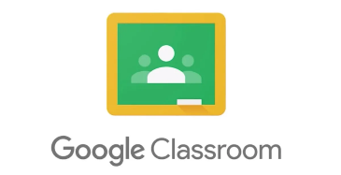
Google Classroom Pupil Use Agreement
The purpose of our Google Classroom is to provide a safe and secure place to receive and share learning, and a place to connect with school staff and classmates. In Google Classroom, school staff can assign work to the students digitally, without paper. Google Classroom is accessible from any digital device with internet access and a web browser. Parents/carers and pupils are expected to read and adhere to the points outlined below.
Responsibility:
• Check Google Classroom every day to view new assignments.
• Complete your learning online by either completing it on a digital device, or by doing it in your book/on paper and submitting a photo of it (or other file, such as video or sound clip, if required).
• Complete the learning provided to the best of your ability.
• Remember to submit learning by clicking ‘Turn in’ on Google Classroom.
• Check and respond to any feedback you may have received from school staff.
Safety:
● Do not share personal information such as e-mail, home address or phone number.
● Only login using your own username/login and password.
● During ‘learning time’, you will be expected to use Google Classroom to access, complete and submit learning. You should not use this time to access other content on the internet unless it is for the learning that has been set by a member of staff.
● Ask permission of a parent/carer when accessing content on different websites or apps.
● When submitting images, sound clips or video, make sure that these are appropriate for the learning task. Check with your parent/carer if you are unsure.
● Tell a trusted adult in school if you receive any messages that are inappropriate or make you feel unhappy.
● When using a loaned device from school, only use it for school work. Do not take photos, other than school-work related for the purpose of uploading to Google Classroom for your teacher to assess.
● When participating in Google Meet via video, ensure you are dressed appropriately, within a ‘living/ dining’ area of your home and with a parent/carer.
Digital Citizenship:
● Google Classroom is to be used for learning and not for social purposes.
● Be polite, friendly, and encouraging in any communication with school staff and other pupils.
● Send polite and responsible messages and think carefully about how online messages affect others.
Comments:
● Make sure your comments are about the learning and that they make sense. Be sure to check and edit comments if necessary.
Pupil’ s Agreement I have read/ listened to a reading of and understood the Google Classroom Pupil Use Agreement and I will follow the rules, which are there to keep me and our school safe.

Pupil Name: ___________________________ Pupil Signature: _________________________

