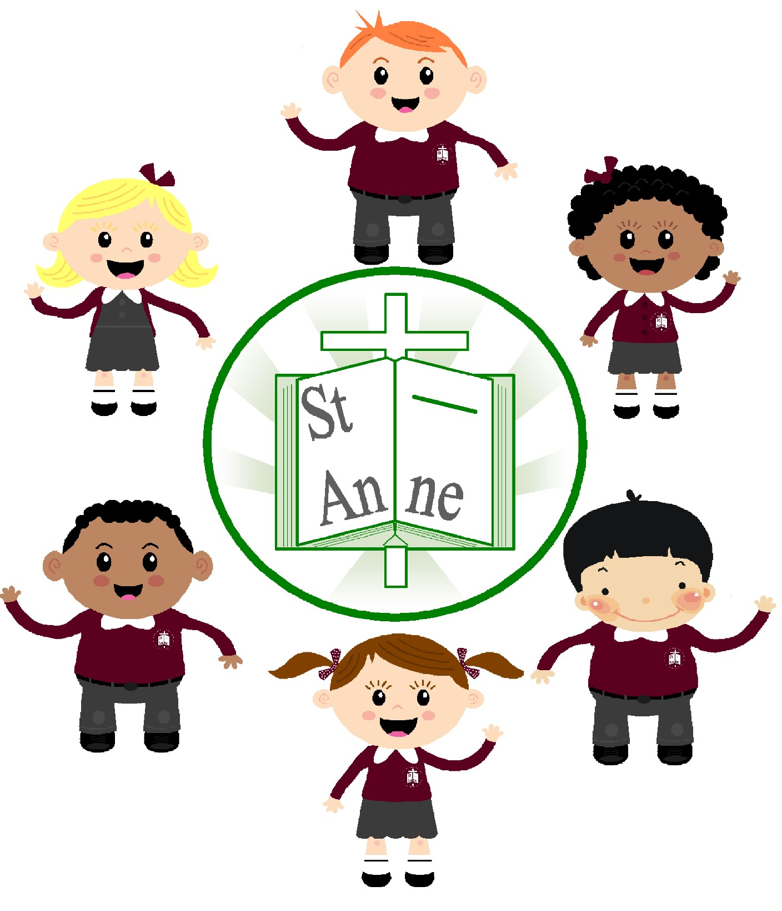

St. Anne (Stanley) C of E School

Religious Education Policy

A Baseline for Achieving Excellence in
RE

September 2020

St. Anne (Stanley) C.E Primary School
Religious Education Policy

1. Intent

Curriculum Vision
RE is central to the purpose of St. Anne (Stanley) because, as a church school, we see that the Christian faith informs all aspects of our life together and commits us to a search for truth. Religious Education and Spiritual development is at the heart of our education process underpinning the whole curriculum, introducing our pupils to faith and belief.

At St. Anne (Stanley) we believe that children are at the heart of everything that we do. As a Church of England Primary School we do our utmost to ensure that all children gain the appropriate knowledge, skills and attitudes for Christian living. We do this by providing a high quality, reflective and respectful curriculum that encompasses the Christian and British values. RE is taught in such a way that it inspires pupils to explore, develop and affirm their own faith and values and have respect for the faith, beliefs and values of others. The children at St. Anne (Stanley) will strive to develop a sense of purpose, awe and wonder and eventually be equipped to make rational decisions about God and His incarnation in Jesus Christ. As well as this, children are taught about a range of religions and learn to respect and ask questions about different religions, traditions and cultures around the world.

Aims of the Subject
This policy and indeed the practice of Religious Education aims to reflect the very nature of our school. At St Anne (Stanley) we promote ourselves to be an Anglican Christian School maintaining and enjoying close links with our parish church St. Anne (Stanley).

The aims of Religious Education at St. Anne (Stanley) are:

- To visit places of worship, especially St. Anne’s Church and the Cathedral to develop the understanding of the church as a living community.
- To become active global citizens and courageous advocates serving their neighbour and community.
- To provide opportunities for personal reflection where children can explore their own beliefs and faith.
- To provide pupils with the opportunity to develop a sense of themselves as significant, unique and precious.
- To encourage children to appreciate and respect the different cultures in today’s society.
- To inspire children to ask and reflect on challenging questions.

School values
Honesty - “And you will know the truth and the truth will set you free.” John 8:32
Friendship - “Greater love has no one than this, that someone lay down his life for his friends.” John 15:13
Hope - “Rejoice in hope, be patient in tribulation, be constant in prayer.” Romans 12:12
Understanding - “Trust the Lord with all your heart, and do not lean on your own understanding.” Proverbs 3:5
Confidence - “Therefore do not throw away your confidence which has a great reward.” Hebrews 10:35
Family - “Honour your father and your mother, that your days may belong in the land that the Lord your God is giving you.” Exodus 20:12 These underpin and are embedded in our curriculum.
In RE, this means:
- Children having confidence in their knowledge and see challenge as a positive.
- Children have an understanding of cultures and religions and show understanding and respect.
- Children develop an understanding of their own spirituality and how the values can help them lead a life in Jesus footsteps.

Cultural capital
Teaching and presentation of R.E is approached in a variety of styles using I.C.T, stories, artefacts, visits, song and music. This is to ensure that all children have the opportunity to participate in R.E regardless of age, ethnic and cultural origin, gender or physical and mental ability. Every provision is made so that all pupils of every ability, SEND, Gifted and talented pupils included can be involved in the learning process at their own level.

Planning and sequencing
Religious Education in a Church school lies at the very heart of the curriculum. The broad content of our R.E teaching is taken from the new Liverpool/Blackburn Diocesan syllabus for primary schools. (Oct 2013). Which reflects the National Framework for RE, the National Society Statement of Entitlement and the Requirement of SIAMS.

- 5% of curriculum time will be devoted to RE 1 hour in Key Stage 1 and 1 hour and 10 minutes in Key Stage 2 per week.
- Christianity will play a central role in RE taking up between two thirds and three quarters of the time available.
- Appropriate teaching about other faiths and world views is included.

At St. Anne (Stanley) Primary School we plan our RE based on the Blackburn Diocesan syllabus. The long and medium term plans ensure that there is progression throughout the school and that children are building upon knowledge learnt in previous years. The topics are designed so that pupils develop knowledge and understanding of the principal religions in Great Britain and Christianity is taught as a core religion in all key stages.

We recognise that within classes, there is a wide variety of abilities and so we provide suitable learning opportunities that are matched to the needs of all children. This is done through providing support, differentiating activities and using a range of teaching and learning styles within lessons. Where possible, teaching will be supplemented with trips to places of worship or visits from people from religious communities.

Curriculum map

TERM | Autumn 1 | Autumn 2 | Spring 1 | Spring 2 | Summer 1 | Summer 2
Nursery and Reception  Including:  Nativity | Friendship: What makes a good friend?  Harvest: Saying thank you to God at harvest time. | I am Special  Christmas: How do we celebrate Jesus’ birthday? | Listening to the stories Jesus heard  Stories Jesus Told: Why did Jesus tell stories? | Easter | Special Places: What makes a place special/holy?  Special Times: How do we celebrate special times? | Prayer: What is prayer?
Pupils in KS1 receive 36 hours of RE per year which is 5% of allocated curriculum time (1hour per week).

80% of the time should focus on Christianity and 20% on the teaching of other faiths (29 hours Christianity and 7 hours’ other faiths).

Year 1  Including:  Family Worship  Easter Service | 1:1 Harvest: How can we help those who do not have a good harvest?  (4+2 hours) | 1:2 God and Creation  (5 hours)  Festivals of Light  Eid/Diwali/Hanukah  (+2 hours) | 1:3 Christmas: Why do we give and receive gifts?  (5 hours) | 1:5 Easter: Celebrating  new life and new beginnings  (5 hours) | 1:4 Jesus was Special  (6 hours) | 1:7 Why is Baptism special?  (4+3 hours)
Year 2  Including:  Family Worship  Easter Service | 2:1 The Bible: Why is it such a special book?  (4+3 hours) | 2:2 Christmas: Why was the birth of Jesus such good news?  (5 hours) | 2:3 Jesus: Friend to  Everyone  (6 hours) | 2:4 Easter: How do symbols help us to understand the story?  (5 hours) | 2:5 Why is the Church a special place for Christians?  (5 + 4 hours) | 2:6 What happened at the Ascension and Pentecost?  (4 hours)
Pupils in Lower KS2 receive 45 hours of RE per year which is 5% of allocated curriculum time (1hour 10 minutes per week).
80% of the time should focus on Christianity and 20% on the teaching of other faiths (36 hours of Christianity and 9 hours of other faiths)

Year 3  Including:  Family Worship  Christmas Service | S2 The Lord’s Prayer  (3 hours)  3:6 Harvest  (3+ 3 hours) | 3:2 Christmas: God with Us  (5 hours) | 3:3 Jesus: The man who changed lives  (6 hours) | 3:4 Exploring the sadness and joy of Easter?  (6 hours) | 3:1 Called by God  (5 hours)  S5 Expressing Christian  Faith through Art  (4 hours) | 3:5 Which rules should we follow?  (4 + 6 hours)
Year 4  Including:  Family Worship  Christmas Service | 4:1 God, David and the Psalms  (6 hours) | 4:2 Christmas: Exploring the symbolism of light  (6 + 2 hours) | 4:3 Jesus: Son of God  (7 + 2 hours) | 4:4 Exploring Easter as a story of betrayal and trust  (6 hours) | 4:5 Are all churches the same?  (6 + 4 hours) | 4:6 What is prayer?  (5 + 1 hours)
Pupils in Upper KS2 receive 45 hours of RE per year which is 5% of allocated curriculum time (1hour 10 minutes per week).

80% of the time should focus on Christianity and 20% on the teaching of other faiths (36 hours of Christianity and 9 hours of other faiths)

Year 5  Including:  Three Eucharist  Services  Harvest Service  Family Worship | 5:1 How and why do Christians read the Bible?  (5+4 hours) | 5:7 Christmas around  the world  (6 hours) | 5:3 Jesus: The Teacher  (6 hours) | 5:4 Why do Christians believe that Easter is a celebration of victory?  (6 hours) | 5:5 Exploring the lives of significant women in the Old Testament  (5+3hours) | 5:8 Daniel, did he make the right choice?  (6 hours)  S7 Change the World  (2+2 hours)
Year 6  Including:  Three Eucharist  Services  Harvest Service | 6:1 Life as a journey and pilgrimage  (6 + 4 hours) | 6:2 How do Christians prepare for Christmas?  (5 hours) | 6:3 Why do Christians celebrate the Eucharist?  (3 hours)  6:3A Why is the Exodus such a significant event in Jewish and Christian history?  (4+3 hours) | 6:4 Easter: Who was Jesus? Who is Jesus?  (4 hours) | 6:5 Ascension and  Pentecost: In what ways do these events and beliefs make Christianity distinctive?  (4 hours) | 6:6 Ideas about God (5+2 hours)  6:7 People of Faith  (5 hours)

Schematic links
Religious Education lends itself to the development of other curriculum areas. In both Key Stages One and Two it can be used to support art, literacy, drama and music. Religious Education will, wherever possible, be used as a link which gives scope for development, where there is not a link, Religious Education will be taught in isolation.

Implementation

High quality teaching and learning
At St. Anne’s (Stanley), we teach R.E both implicitly and explicitly. The Christian ethos of our school is one of caring and sharing, which permeates in all we do. In covering the two attainment targets of learning about and from the Christian faith, the children will develop their capacity to use all their senses and be prompted to think, question, explore, experience, reflect, feel, wonder, enjoy and value and respond to the issues they face both in and out of school.
It is essential that the Religious Education curriculum maintains a balanced approach of Learning about Religion (AT 1) and Learning from Religion (AT 2).

Learning about Religion
We learn about:
- God who reveals the truth about himself and humanity through creation, the giving of the law, his action in history and through the prophets.
- God who reveals himself ultimately in Jesus his son, living among us and dying and rising for us.
- God who reveals himself in his Spirit working in the living faith of the church experienced through scripture, tradition and reason.

Learning from Religion
We learn from:
- An empathetic response to the Christian faith and critical engagement with it.
- Responding personally to the stories and teachings of Jesus Christ.
- Examples of Christian living which give priority to the values of unconditional love, forgiveness, reconciliation, compassion and faith.

Religious Education in our school should also help pupils to:

- develop the skills to handle the Bible Text.
- begin to develop their own commitments, belief and values.
- engage in thoughtful dialogue with other faiths and traditions.
- find a reason for hope in a troubled world.

Other Faiths
It is entirely appropriate and necessary in today’s world that children should be encouraged to foster a respect for the followers of the other world faiths. It is essential that this respect is based on an accurate and sympathetic understanding of those faiths.

R.E in our school should help pupils to:
- Learn about other faiths, their beliefs, traditions and practices and from them through encounter and dialogue.
- Recognise and respect those of all faiths in their search for God.
- Recognise areas of common belief and practice between different faiths.
- Enrich and expand their understanding of truth while remaining faithful to their own tradition.
- Enrich their own faith through examples of holy living in other traditions.

The R.E coordinator will keep abreast of new publications and developments within the subject and in the teaching of R.E in both Foundation Stage and Key Stages 1 and 2, also attending any related training courses.

The R.E coordinator will observe the teaching of R.E across the school and monitor the planning and work on a regular basis. A Scrapbook will be kept by the coordinator of work/photographs in R.E across the school. They will also report findings in written format if needed or where appropriate in staff meetings.

Opportunities to develop subject specific literacy
At St Anne (Stanley) staff are aware of the importance of children being exposed to a wide variety of vocabulary. RE specific vocabulary is demonstrated by staff in lessons as well as highlighted, referred to and cross-curricular links are made where appropriate. Staff model subject specific vocabulary, allowing children to contextualise it across the curriculum.

All staff provide good models of spoken English to help the children enlarge their vocabulary and learn how to structure comprehensible sentences, speak confidently and clearly.

Progress – knowing more and remembering more
To guarantee that progress is made for all children in Religious Education, the staff at St Anne (Stanley) plan their lessons using the Blackburn Diocese Syllabus. We are able to embed the knowledge required through following a teaching sequence and through lively, interactive and investigative lessons. We consistently build on the children’s prior learning to deepen their understanding and build confidence in their own ability. Planning from the previous year group and the subsequent year group is provided to teachers to make them aware of prior and future learning. RE specific vocabulary and skills are modelled consistently and progressively by staff. Knowledge organisers are accessible in RE books which highlight the subject specific vocabulary for each topic.

Assessment
It is important throughout the 3 Key Stages that activities build on what has gone before, demonstrating genuine progression and continuity. This is achieved by adhering to set schemes of work, progression within individual lessons and also coherence between Collective Worship and aspects of the R.E curriculum.

We assess children’s knowledge and awareness of the subject on a regular basis by observing their interactions and relationships with others, by questioning and listening to them and by looking at pieces of work. Work will be recorded individually and in a class scrapbook.

At St. Anne (Stanley) we will use the 8 level descriptors to know where the children are at in our class. Teachers will be aware of what level their children are working at. Written comments will be marked against R.E skills and the end of year report should make a comment on the appropriate R.E level the child is working at. Staff report on the progress of their class at the end of each topic and this is then passed to the RE coordinator. This information will then be used by the RE coordinator to collate the progress and attainment of each child throughout the year.

Learning environment
In St Anne (Stanley) the children’s work and achievements will be celebrated through displays in classrooms, corridors and in their class books. The displays and worship areas contain examples of children work, key vocabulary, a range of appropriate resources and prayers. Collective Worship and RE scrapbooks for each year groups can be accessed in these learning environments.

Around the school children have access to RE and value related displays and maps. These are placed age appropriate for EYFS, Key Stage 1 and Key Stage 2. Throughout the year the RE Coordinator will place questions and facts on these displays making them interactive.

The displays/worship areas are utilised when and where appropriate to support the learning process and prayer. Dedicated display areas in each classroom are expected across the school and are present in each classroom.

Reading
The ability to read is embedded throughout the curriculum at St Anne (Stanley) and the children are given many opportunities to develop their understanding through a rich and diverse programme of learning. Children are taught to read from an early age and they are given the opportunity to develop their reading skills in all subject areas including Religious Education.

Inclusion
At St Anne (Stanley) we believe that it is important for all children to have opportunities to develop their spirituality in a safe environment. In line with equal opportunities we are committed to providing a teaching environment that promotes learning. Religious Education forms part of the school curriculum policy to provide a broad and balanced education for all children. We plan for and teach Religious Education to all children, whatever their learning needs, this provides children the opportunity to achieve their full potential. We ensure that learning opportunities are provided for the needs of children to make progress by setting suitable learning challenges, differentiated tasks, resources and outcome.

Children are given opportunities to work with others, listen to each other and treat everyone with respect. We plan our classroom activities to challenge and involve all children appropriately, according to age, gender, capability, ethnic diversity, and language background. Teaching is adapted to reflect children’s different learning styles. We use materials for teaching which avoid stereo typing and bias towards race, gender, role or disability. We deal with such issues clearly and sensitively if/when they do arise.

Through our Religious Education teaching we provide learning opportunities that enable all pupils to make progress. We use a range of strategies to support children and ensure their needs are catered for in each aspect of the curriculum. Strategies particularly relevant to Religious Education are:

- The use of several levels of difficulty of vocabulary in class lessons by the teacher e.g. resurrection, raising, restoration
- Modified text passages and age appropriate resources e.g. Bibles with suitable texts for the age range and abilities.
- Different levels of written or oral questions for children investigating photographic or other visual materials.
- Careful use of support for children with English as an additional language. ➢ Multiple ways to access prayer e.g. individual, written etc.
- Using a variety of learning styles to suit children’s learning preferences e.g.
drama, hot seating, questions, mind maps etc.

All staff at St Anne (Stanley) have high expectations of each and every child. For our gifted and talented pupils’, we encourage them to think creatively, explore and develop ideas and try different approaches. Pupils should be encouraged to ask and answer their own questions, offer ideas, suggest solutions or explanations, and reflect on what they have heard, seen or done in order to clarify their thoughts. Children will be encouraged to show greater independence in their work, for example carrying out a religious enquiry and comparisons.

SMSC/British Values
The teaching of Religious Education is an integral part of the wider curriculum. It provides scope for spiritual, moral, social and cultural development of the pupils at St. Anne (Stanley) (see separate policy), Many skills are developed through R.E that are essential for extending learning in other areas. Equally other subjects can generate a greater understanding for learning from and about religion.

SMSC plays a significant part in a child’s ability to learn and achieve. Religious Education is an integral part of the curriculum and it therefore makes a contribution to the child’s spiritual, moral, social and cultural development. All adults will model and promote expected behaviour during RE lessons, treating everyone as a valuable individual and showing respect for children and their families. Children will understand the need for rules and the need to abide by them for the good of everyone. School and classroom rules reflect, reiterate, promote and reward acceptable behaviour and provide opportunities to celebrate children’s work and achievements in RE.

‘A Spiritual sense can be seen as a pre - requisite for learning since it is the human spirit that motivates us to reach beyond ourselves…’ (SCAA)

PSHE and Citizenship
At St Anne (Stanley), Religious Education contributes to the teaching of PSHE and Citizenship. Firstly, the subject lends itself to raising matters of citizenship and social welfare. It encourages our children to celebrate difference and diversity and teaches them the importance of resect and understanding. Secondly, the nature of the subject means that children have the opportunity to take part in debates and discussions. We help children to develop their knowledge and understanding of different cultures so that they learn to avoid stereotyping other people and acquire a positive attitude towards others.

Enrichment
To enrich and enhance the teaching and learning of Religious Education in our school, we incorporate field trips wherever possible and appropriate. Each class will undertake at least one trip per year.

We enable all children to participate in activities outside the classroom including afterschool clubs. Our Worship Warriors Club enables the pupils to lead Assemblies/ Collective Worship for other children, look at the teaching and values found in the Bible in greater depth and provides a chance for the pupils to develop their own spirituality further.

Children are readily encouraged to discuss their own personal trips and share their knowledge of different places with their peers.

Homework
Homework is not set specifically for Religious Education every week. It is given to children where and when necessary and always relates to the topic that the children have been learning.

Withdrawal
Parents have the legal right to withdraw their child from R.E if they wish. The Worship and Religious Education provided by our school is in accordance with the Church of England ethos and Liverpool/Blackburn Diocese Syllabus. This is reflected in our curriculum and the whole life of our school community. Since the conduct of our school as a whole reflects the Church of England Ethos, removal of pupils from Worship and or Religious Education cannot insulate them from the religious life of the school. If such a request is made, the Head teacher should explore the reasons for the request and seek to arrive at an appropriate solution. If needed appropriate alternative arrangements will be made for the supervision and tasks set for the child in question. Records of children withdrawn will be kept by the Head teacher.

Impact: what will our children look like?
At St Anne (Stanley) we want children to thoroughly enjoy their RE lessons and be able to use the skills, knowledge and teachings they have acquired in their future lives to live in Jesus’ footsteps. When planning lessons, we hope to contribute to our children being creative, confident, inquisitive and resilient learners. That are ambitious yet compassionate and respectful. We encourage our children to try new things and undertake new life experiences both now and in the future.

Role of the RE Coordinator
Each subject leader checks and monitors the delivery and impact in their subject area. If there are gaps, the relevant year group’s teachers and the Curriculum Coordinator are informed to ensure comprehensive coverage.

The role of the Subject Leader is to:
- Provide a strategic lead and direction for the subject.
- To ensure that progression is planned into schemes of work.
- Keep up to date with developments in the subject, at both national and local level. ➢ Support and advice colleagues on issues related to the subject.
- Monitor children’s progress in the subject area.
- Review the way the subject is taught in the school, and plan for improvement.
- Keep sample evidence of the children’s work demonstrating the expected level of achievement in the subject in each year of the school.
- Provide efficient resource management for the subject.
- Have an awareness of the schemes of work from EYFS to KS2.
- Report to the Head teacher and Governors on the strengths and areas for development of the subject and the strategies for improvement.

Name: K. Broughton
Subject Coordinator
This policy will be reviewed every two years.

Date of Review: September 2020
Approved: September 2020
Review Date: September 2022

