St Anne (Stanley) CE Primary & Nursery School
Prescot Road
Liverpool
L13 3BT
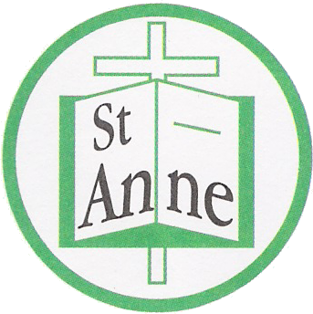

Tel : 0151 228 1506
Fax : 0151 228 85

Email: Stanley-ao@st-annesstanley.liverpool.sch.uk

11th January, 2020
Dear Parent or Carer,
We have been advised by Public Health England that there is a confirmed case of COVID-19 within our school community.
I would like to take time to reassure you that we have taken all necessary actions since hearing this information to keep all children at our school as safe as possible. The children and staff in the bubble now self-isolating for 14 days and the school has been cleaned appropriately.
How to stop COVID-19 spreading
There are things you can do to help reduce the risk of you and anyone you live with getting ill with COVID-19
· wash your hands with soap and water often – do this for at least 20 seconds
· use hand sanitiser gel if soap and water are not available
· wash your hands as soon as you get home
· cover your mouth and nose with a tissue or your sleeve (not your hands) when you cough or sneeze
· put used tissues in the bin immediately and wash your hands afterwards
Further Information Further information is available at https://www.nhs.uk/conditions/coronavirus-covid-19/
Symptoms of COVID 19
The most common symptoms of coronavirus (COVID-19) are recent onset of:
· new continuous cough and/or
· high temperature and/or
· a loss of, or change in, normal sense of taste or smell (anosmia)
For most people, coronavirus (COVID-19) will be a mild illness.
If your child does develop symptoms, you can seek advice from NHS 111 at https://www.nhs.uk/conditions/coronavirus-covid-19/check-if-you-have-coronavirus-symptoms/or by phoning 119.
Yours sincerely,
Headteacher

