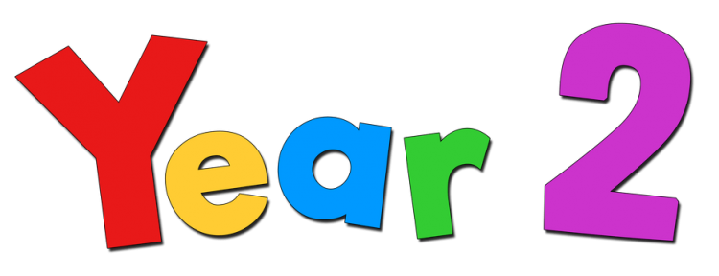

Dear Parents/Carers,
Well done for getting through another week of home learning. Here are a few more ideas that may help with this week’s home learning tasks. As always we recommend TT Rockstars, Reading Plus, Education City. I have also attached new Home Learning Packs to this email for English, Maths and Spelling. There are also some short reading and comprehension activities in the file attached.
Here are details of an art competition being run by Mrs Bell in Year 1. It is for all children across the school. The children can simply create a piece of artwork expressing their experience of this extraordinary time. While there will 1st, 2nd and 3rd prizes, we will publish every entry on the Art and Design web page. That way, every child's work is celebrated. Children can take part in the hub or at home (parents could email a photo of their children's artwork). If you would like to take part, please forward photographs of the children's artwork to me and I will pass them along to Mrs Bell. The deadline is the 3rd of July.
More activities;
https://www.robinhoodmat.co.uk/learning-projects (It has daily lesson ideas and projects)
https://www.writingonthewall.org.uk/resources.html (Ideas for writing activities)
https://www.liverpoolmuseums.org.uk/stories/collecting-and-representing-covid-19-your-museum-needs-you (Here is a chance for you to become part of history)
https://www.liverpoolmuseums.org.uk/my-home-my-museum (Create your own museum or art gallery at home)
https://www.davlae.co.uk/ (Lots of templates and resources to make your own learning games)

We will continue to use Twitter (@stannestanleyy2) to share activities and it allows the Year 2 team to see what lovely activities everyone has been up to.

If you have any questions, please do not hesitate to contact us.
We miss you all very much and look forward to seeing you when we do return to school.
Stay safe and take care.
Miss Broughton, Miss Search and Mrs Crawford

