As you have probably heard the adults around you saying, this is a funny time for all of us!
Let’s make sure you don’t forget it by writing a few things down.

All about you
Draw or stick a picture of yourself here.
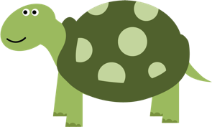
How old are you? | I am years old.
How tall are you? | I am cm tall.

Who lives with you?
Who are your best friends? | My best friends are
What do you like doing in normal life? | I like

All about lockdown

How did you feel when your school closed? Circle your answer. | Pleased  Sad  Worried  Something else
How do you feel now? Can you describe your feelings or draw a picture to show them?
Are you doing anything different in lockdown? Write about it or draw a picture to show what you’re doing.

What do you like about lockdown? | I like
What don’t you like about lockdown? | I don’t like
Finally, what three things are you most looking forward to doing after lockdown?

