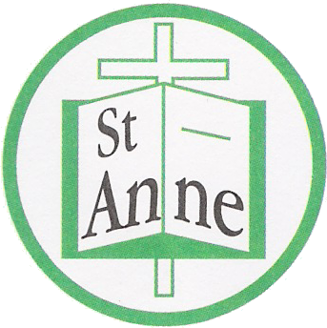
St Anne (Stanley) C of E School
Prescot Road
Liverpool
L13 3BT

Tel : 0151 228 1506
Fax : 0151 228 8581

Email: Stanley-ao@st-annesstanley.liverpool.sch.uk

Monday 27th April, 2020

Dear Parents/Carers,

I hope you and your families are all safe and well and have been enjoying some of the lovely weather we have had recently.

We still do not know a date of when our school will open again but please be assured we will let you know as quickly as possible.

To help with children learning at home we have provided a link on our school website under latest news – home learning to a site called Oak Academy on line (a site recommended by the government). This site provides daily lessons in English and Mathematics for all year groups from Reception – year 6 and beyond with many tutorials to help our children too.

For children in Early Years don’t forget we have ‘EasyPeasy’ which provides lots of activities to support learning at home – sent via a text message. Having a daily routine for learning will help our children not only now but when they return to school. The children also have access to TT rockstars, reading plus, education city and a wide range of resources that we continue to update on our school web site and/or class pages. We also appreciate that this is a time when children can enjoy spending family time together – playing games, baking cakes and learning new important skills – I’m sure they are having lots of fun.

For parents entitled to free school meals, you should have received an email from EDENRED that will enable you to access vouchers to use at various supermarkets. The school ordered 4 weeks for each family. Please check your emails – including the junk box for the notification to come through.

What we need you to do
- If you’ve recently changed your contact details, please inform the school office as soon as possible via email or through the school mobile number 07716711416.
- Talk to your children about the coronavirus. It’s a scary time and we should make sure children feel supported. BBC Newsround has regular updates for younger children and YoungMinds has practical steps older children can take to help with anxiety. We have lots of resources to support with mental health and wellbeing on our school home page.

If you have any questions
Please consult the:
- School office via email or via the school mobile number : 07717711416 listed above.
- NHS, if you want to know more about the symptoms of coronavirus. If you think you or your child may have the symptoms, use NHS 111 online if at all possible before calling 111
- Department for Education’s coronavirus helpline: 0800 046 8687, if you have any questions about the government’s response to coronavirus in relation to schools
- Government’s travel advice, if you want to know whether any upcoming trip or holiday you’re taking abroad should go ahead

It’s a tricky time and we know you’re worried about the impact this might have on our community. It’s important we keep each other safe and talk about these events to help with any anxiety. If I can do anything to support you during this time, please do not hesitate to contact me either on the school mobile number above or through my school email j.simons@st-annesstanley.liverpool.sch.uk.

Please be assured that we will all continue to support our children and families throughout the time our school is closed. Hoping you and your families remain safe and well throughout this time.

Thank you for your continued support.

Mrs. Julie Simons
headteacher

