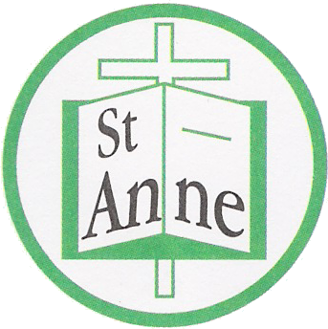
St Anne (Stanley) C of E School
Prescot Road
Liverpool
L13 3BT

Tel : 0151 228 1506
Fax : 0151 228 8581

Email: Stanley-ao@st-annesstanley.liverpool.sch.uk

Monday 18th May, 2020

Dear St. Anne’s families,

Since the announcement by the Prime Minister informing that all schools would be open from June 1st, there have been many changes. As you can appreciate it was a difficult time because the school heard of this information at the same time as the general public. We have really valued your overwhelming support and patience during this time of uncertainty.

In response to the Government's announcement, our Local Authority has worked extremely hard alongside the various unions and headteacher associations to provide a city wide approach which was shared with all schools at the end of last week. Over the weekend we received full guidance.

Liverpool Approach:

- As of the 22nd of May all Liverpool Safe Space Hubs will close.
- There will be no school provision during the May half term. (Monday 25th - Friday 29th May)
- As of 1st June schools to open for child care to their own pupils of Key Workers and Vulnerable Children only, where other safe child care is not available. (The definition of key worker remains unchanged).
- Subject to review and where safe to do so, small groups of year 6 pupils may be introduced each week commencing 15th June. (We await further communication from the Local authority relating to this date)
St. Anne Stanley Plans:
Our school will reopen to the pupils of Key Workers and Vulnerable children, who have previously accessed hubs across the city on June 2nd.
- During Monday 1st June, staff will be preparing classrooms and the wider school site for the safe return of our children.
- All staff will receive full health and safety training in line with government and local authority guidance.
- Rigorous risk assessments are to be carried out this week by our registered Health and Safety Company. The risk assessments will be ongoing throughout the summer term. School will adhere to all recommendations to ensure the safety of our children, staff and parents.
- The school office will not be accessible to parents – please communicate via the member of staff who will greet the children each day – stationed at the pupil entrance (using recommended social distancing measures) or preferably by phone or email.
- The building although cleaned after closure will have a thorough deep clean during half-term week.
- All areas of the school building will be cleaned daily including door handles, handrails, surfaces etc.
- Class sizes will be kept to a maximum of ten children.
- If or when numbers increase – the school will ensure that different starting and finishing times along with separate entrances to school are utilised to minimise the contact between different groups of children and adults. We will also operate split breaks and lunch times.
Daily Routines:
- Children to arrive at 8:45 a.m. – 3:15 pm
- Children should wear a fresh set of clothes each day (non-uniform)
- A choice of hot or cold lunch will be available
- Children will need to bring a bottle of water – which they will be able to refill throughout the day
- Please apply sun lotion before your child attends schools
Learning activities in school:
- Children will have access to reading and number activities similar to the online learning resources offered to all pupils at home. A range of enjoyable activities will take place throughout the day using the outdoor spaces whenever possible.
Home learning for those children not in school
- Home learning will continue in the same form as previously. If you are finding it difficult to access on-line information, please contact the school.
The Local authority have insisted they will not be pressuring any parents to send their children to school during this term. You know your own children and their personal situation best. The government have also made it clear that they will not be fining parents who choose not to send their child to school during this time.
Whilst we are really looking forward to seeing our children again, their safety and that of our staff, parents and our community will always be our highest priority. Any future decision will always be carefully considered with safety at the forefront of this.
If there is anything at all you would like to ask or raise, please email me on j.simons@st-annesstanley.liverpool.sch.uk .
Thank you as always for your continued support, I realise that this is a difficult time for everyone. I will continue to keep you informed as the situation progresses.
I hope you and your families all remain safe and well.
Yours sincerely,
Julie Simons
Headteacher

