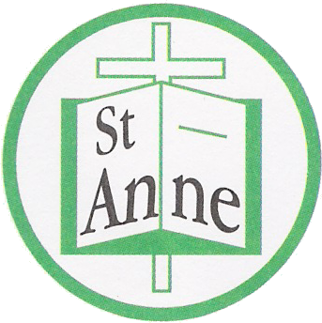
St Anne (Stanley) C of E School
Prescot Road
Liverpool
L13 3BT

Tel : 0151 228 1506
Fax : 0151 228 8581

Email: Stanley-ao@st-annesstanley.liverpool.sch.uk

8th June, 2020

To all our amazing St. Anne’s children,

Hello everybody,

I hope you are all safe and well.

I am sure over the last few weeks you have really enjoyed the wonderful sunshine. Although the weather is not as nice at the moment, let’s hope we will have lots of nice weather soon. Make sure, you continue to look after yourselves and your family – lots of smiles – remember how infectious these are? One smile brings so many more – and it makes us feel better too. I want you to see how many lovely smiles you can give to your family each day – and from a distance to others too. I hope you count at least twenty of these per day!!

Myself and all the staff are all really missing you. It’s far too quiet without you all in school! We really can’t wait for you all to come back but unfortunately it still isn’t possible just yet. We are however, preparing for when you do return, getting things ready for when we see your lovely smiling faces again. You can help with this too, what would you like to do most when you return? What are you missing most? Make sure you let your class teacher know all of your ideas – so we can make a plan to include as many ideas as possible. I know many of you still ask me about a swimming pool on the roof – we still cannot have this I’m afraid –imagine having a leak from a swimming pool!!! Instead try to think of things that you know we might be able to do, I’m sure you can think of something.

I hope you have been enjoying lots of nice times at home with your families and are being helpful around the house. This is a great time to find a book to read or share– there are lots of on-line stories that can be read to you too – how wonderful is that? We also have lots of on line activities that your teacher will have told you about – and many more on our school website. You can also still follow the recipes of Classroom kitchen too, draw some lovely pictures, recycle and make new things – I like some of the ideas of how to use empty toilet rolls below. But, I’m sure you can think of other ideas too.

Send pictures to your class teacher, friends or through our school twitter – we love seeing all of your lovely designs and creations.

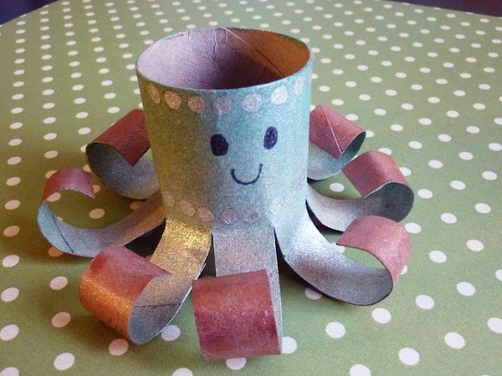

It is also really important that you continue to wash your hands regularly throughout the day – we will be continuing to do this in school too. Remember to keep your distance from everyone when you go out, this is to make sure that you and your families don’t catch any virus germs at the moment.

I hope you are all helping out at home with the tidying of your rooms or toys and being extra helpful to your lovely families. Remember it is important that we stick to our routines – including morning and night times – as your parents tell you and try to get as much exercise as possible and drinking lots of water so that we stay healthy and well.

A lot of you have spoken on the phone to friends or family and even your class teachers which is lovely. Remember that although we might not have seen you for a while – we are always thinking about you and missing you loads.

Take care of yourselves and your family.

With lots and lots of love to you all.

Mrs. Simons and all the staff of St. Anne’s (Stanley)

WE MISS YOU!

