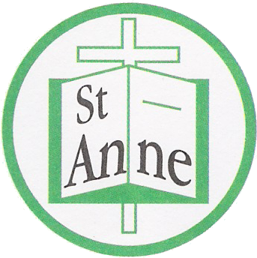
St Anne (Stanley) C of E School
Prescot Road
Liverpool
L13 3BT

Tel : 0151 228 1506
Fax : 0151 228 8581

Email: Stanley-ao@st-annesstanley.liverpool.sch.uk
27th April, 2020

To All our wonderful, amazing children,

The staff and myself are missing you so much and are really looking forward to seeing you all when we eventually return to school. We would like to plan some special things we can do to celebrate seeing each other again. I’m sure you can all help provide us with lots of ideas for this. In the meantime, we know that we have to do our best to keep everyone healthy and that means not coming to school for a little while longer.

Just because you are not in school does not mean that we are not thinking of you, your teachers have already given you work so that you can keep on learning and practising those skills you are so very good at. We have also put lots of things on our school website so that you can use the online resources, watch videos, play games and do tasks on your tablet or computer.

From this week we want you to try out the daily lessons on Oak Academy Online. You can either google this or go to our website and find latest news then home learning – I’m sure an adult will help you to do this. You will find daily lessons for English and Maths for your year group. Don’t forget we also have the TT rockstars and if you are in the juniors you can continue to use Reading Plus.

There are lots of things on our school website home page and on your class pages for you to try. I am sure you can do lots of other lovely things too such as drawing, playing games, baking cakes and spending lots of lovely time with your families.

Most importantly we want you to stay happy and healthy while you are off so make sure you remember all the things that we do in school to achieve this
- Handwashing for 20 seconds with soap and water
- Catching those sneezes and coughs in a tissue or in your elbow
- Eating well and drinking lots of water
- Exercising every day (remember Supermovers or Joe Wicks is doing a workout at 9am every morning)
- Keep your mind healthy too, do some work every day to keep you busy
- Do something silly to put a smile on your face every day, sing loudly, dance like no one is watching
- Remember to calm your mind with some deep breathing, mindfulness or yoga

I’m not sure when we’ll have our lovely school back to normal again but we’ll let your grown-ups know as soon as we know.

Stay safe everyone - we hope to see you soon.

Mrs. Simons
Headteacher

