St Anne (Stanley) CE School
Prescot Road
Liverpool
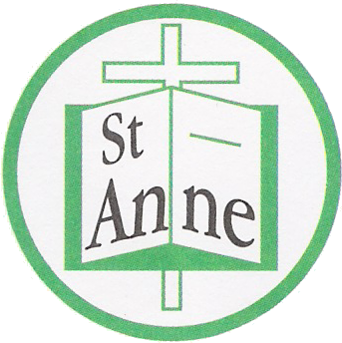
L13 3BT

Tel : 0151 228 1506
Fax : 0151 228 8581

Email: Stanley-ao@st-annesstanley.liverpool.sch.uk

22nd May, 2020

Dear Parents/Carers,
I hope you and your family are keeping safe and well.
Further to my recent letter and the one from Steve Reddy, I am writing to remind you that Liverpool City Council have instructed that all Liverpool Schools will open as hubs for vulnerable children and children of Key Workers ONLY, after the half-term break. For our school, this will mean that the hub will be open from Tuesday 2nd June 2020.
During half-term, children will not be expected to complete any work, unless of course they are keen to do so, but they should concentrate on having some fun with their family. If you do decide to use local parks, then please remember to maintain social distancing to keep yourselves safe.
Whilst we are operating as a hub, there is an emphasis on child care and not academic learning. Hubs should only be used where there is no other alternative child care. If you fall into either of these categories, then you should have already contacted myself by email (j.simons@st-annesstanley.liverpool.sch.uk) to ensure you have a place. Currently we are planning ratios and timetables carefully to enable us to minimise the risk posed for children, staff and parents when they attend the hub.
Our hub will have a first aider on duty at all times. If your child displays any symptoms of Covid-19, they will be isolated in a designated room and you will be contacted to collect them immediately and advised to remain at home following government self-isolation guidelines.
Whilst in the hub, the children will be arranged in to small ‘bubble’ groups, with the same two adults and classroom all week. The groups will not mix with any other group of children in either the building or outdoor spaces. Following health and safety guidance, when in the classrooms children will be expected to sit at a desks placed at 2m intervals apart. For our youngest children 2m social distancing measures will be maintained, where possible.
We are also planning and preparing activities to ensure the children who attend our hub, will have lots of fun and plenty of outdoor physical activities. Hopefully, we will be able to use our outdoor spaces as much as possible.
We will be working with LCC on a plan to ensure that other children will only return to school when it is safe to do so. Due to the size of our classrooms, the number of returners will be kept much smaller than the government recommended of 15 per class. We will have no more than ten children in any group and some of our smaller classrooms will only accommodate a group of seven children.
In the meantime, please encourage your children to continue with their home learning activities as directed by your teacher. Remember to also have some fun too!
Please continue to check your emails for messages from your child’s class teacher and any further updates.
We look forward to a time when our St Anne’s school family will be together again.
Kindest wishes to you all, stay safe and well.

Julie Simons
Headteacher

