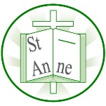
Words of the Week

To widen the children’s vocabulary, we have been introducing ‘words of the week’ in class. The word’s meanings are discussed and they are referred to throughout the week. Children are rewarded if we hear or see them using the words in the correct context. The children enjoy widening their vocabulary, so we thought you might like to continue this at home.
Our words this week are:
Policy
Principle
Significant
Affect

Here are some activities that you might like to try with your child.
Can you use this word in a sentence?
Does it look like another word you know?
How many syllables does the word have?
Can you use this word in a question?
Can you think of any rhyming words?
Can you find another word in this word?

Many thanks
Y5 Team

