Educational YouTube Channels
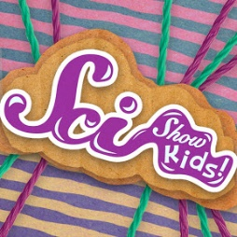
SciShow Kids (Science) https://www.youtube.com/user/scishowkids/videos

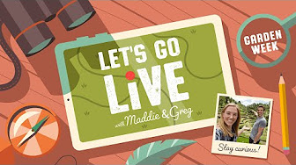
Go Live with Maddie and Greg (Science) https://www.youtube.com/playlist?list=PLmTANLv-GyXWvII2La-sXEePmN2PC9H3g

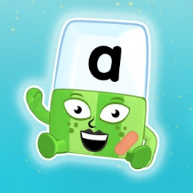
Alphablocks (Phonics)
https://www.youtube.com/channel/UC_qs3c0ehDvZkbiEbOj6Drg/videos

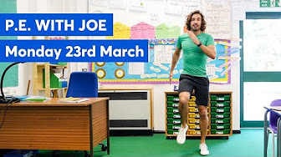
P.E. with Joe Wicks (Sport)
https://www.youtube.com/playlist?list=PLyCLoPd4VxBvQafyve889qVcPxYEjdSTl

Cosmic Kids Yoga (Mindfulness) https://www.youtube.com/user/CosmicKidsYoga/videos
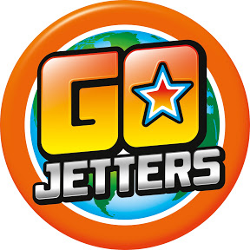
Go Jetters (Geography)
https://www.youtube.com/channel/UCmpFvRQSMIhBKtcFYb-qv_w/videos
Go Noodle Get Moving (Sports/Mindfulness)
https://www.youtube.com/user/GoNoodleGames/videos
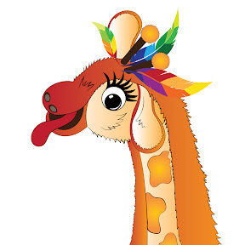
Mr Thorne’s Phonics (Phonics)
https://www.youtube.com/user/breakthruchris/videos

