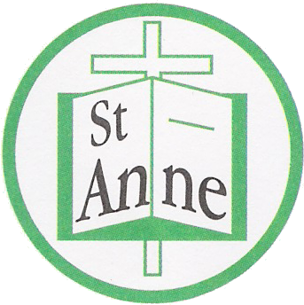
St Anne (Stanley) C of E School
Prescot Road
Liverpool
L13 3BT

Tel : 0151 228 1506
Fax : 0151 228 8581

Email: Stanley-ao@st-annesstanley.liverpool.sch.uk

11th May, 2020

Dear St. Anne's family,

Last night, the Prime Minister announced the possible opening of schools on June 1st for Reception, Year 1 and Year 6 pupils.

I really appreciate that this might give rise to many further questions and uncertainties which unfortunately, we are unable to answer at this given time. As soon as we have more information and guidance from the Department of Education we will let you know as quickly as possible. In the meantime, our school remains closed.

Whilst, we are really looking forward to seeing our wonderful pupils again, we want to ensure that our school is a safe place for everyone. As soon as there is clarity, we will share this with you.

Hoping you all remain safe and well throughout this difficult time.

Warmest wishes to you all.

Julie Simons
Headteacher

