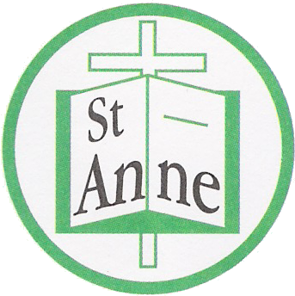
St Anne (Stanley) CE Primary & Nursery School
Prescot Road
Liverpool
L13 3BT

Tel : 0151 228 1506
Fax : 0151 228 8581

Email: Stanley-ao@st-annesstanley.liverpool.sch.uk
16th September, 2020

Dear Parents/Carers,

Due to the current situation, it is possible that at some point in the school year a class bubble might have to isolate should a child or member of staff test positive for Covid 19. Whilst we are doing everything possible in school to keep our children, staff and families safe, we have to be prepared for this possibility.

The disruption to learning in the last term was unprecedented and whilst the school was able to support with a range of on line and paper based learning, we now want to ensure all our children have access to the full curriculum for this year.

We have a ‘Recovery Curriculum’ in place to support with any missed learning opportunities last term. In order to ensure that your child reaches their full potential, it is important that if they have to isolate and are fit and well that they continue with this curriculum.

We continue to provide school access to Oxford Owl, Reading Plus, TT-Rockstars and Education City. On line learning is still available for your child to access through Oak Academy learning and Read, Write Inc. for support with phonics and reading.

To support with home-learning we are arranging to use Google Classrooms. This is a learning platform which will allow us to provide work so that learning can continue as close to normal as possible. Teachers will be able to assign and assess work, providing feedback where necessary.

To access Google Classrooms, your child will need access to either a laptop or iPad. Please complete and return the attached form to inform us if your child has access to an electronic device to support with home learning. We are gathering this information to enable us to set up a loan system, where if your child does not have access to a device at home, school would be able to loan a device for the isolation period. This would be arranged under a contract with the school.
Thanking you in advance for your continued support.
Yours sincerely,

Julie Simons
Headteacher
Please complete and return to school by Friday, 18th September.

Name of child…………………………………………………. Class…………………………………………………
My child has access to an electronic device Yes/No
My child would need to loan an electronic device (under contract with the school) should he/she have to isolate. Yes/No
Wifi is available in our home Yes/No

