ST ANNE’S (STANLEY) JUNIOR MIXED AND INFANT SCHOOL

Summary of responses to
Parent Questionnaire 2019
Contents
The Questionnaire 3
My child is happy at school. 3
My child feels safe at school. 3
My child makes good progress at school. 4
My child is well looked after at school. 4
My child is taught well. 5
My child receives appropriate homework for their age. 5
The School makes sure its pupils are well behaved. 6
The School deals effectively with bullying. 6
The School is well led and managed. 7
The School responds well to any concerns I raise. 7
I receive valuable information from the School about my child's progress. 8
I would recommend the School to another parent. 9
What do we do well? 10
What can we do better? 12

The Questionnaire

My child is happy at school.
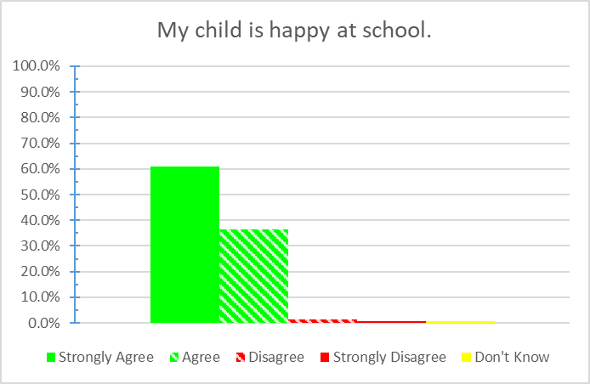
Chart 1: Parent response to 'My child is happy at school.', 2019 Parent Questionnaire.
97.6% of parents responding believed their child was happy at school, with 61% saying they strongly agreed.
1.2% of parents responding did not feel their child was happy at school, and 0.6% said they strongly disagreed. 0.6% of parents responding did not know if their child was happy at school.

My child feels safe at school.
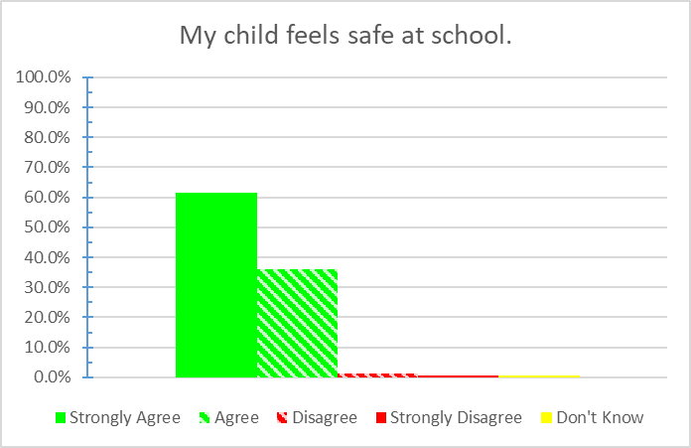
Chart 2: Parent response to 'My child feels safe at school.', 2019 Parent Questionnaire.
97.6% of parents responding believed their child felt safe at school, with 61.6% saying they strongly agreed.
1.2% of parents responding did not feel their child felt safe at school, and 0.6% said they strongly disagreed. 0.6% of parents responding did not know if their child felt safe at school.

My child makes good progress at school.
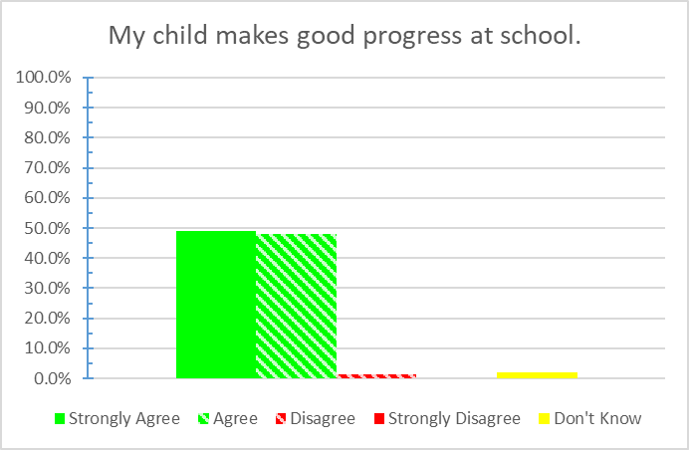
Chart 3: Parent response to 'My child makes good progress at school.', 2019 Parent Questionnaire.
96.9% of parents responding believed their child was making good progress at school, with 49.1% saying they strongly agreed.
1.2% of parents responding did not feel their child was making good progress at school, and 1.8% of parents responding did not know how their child was progressing.

My child is well looked after at school.
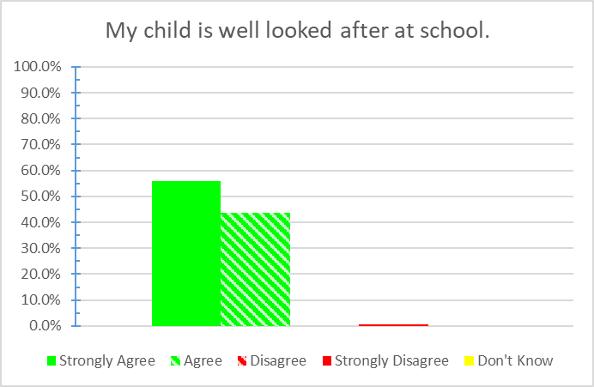
Chart 4: Parent response to 'My child is well looked after at school.', 2019 Parent Questionnaire.
99.4% of parents responding believed their child was well looked after at school, with 55.8% saying they strongly agreed.
0.6% said they strongly disagreed that their child was well looked after at school.
.

My child is taught well.
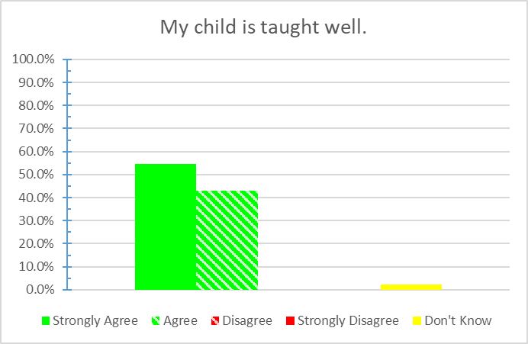
Chart 5: Parent response to 'My child is taught well.', 2019 Parent Questionnaire.
97.5% of parents responding believed their child was taught well at the school, with 54.6% saying they strongly agreed.
2.5% of parents responding did not know how well their child was being taught.

My child receives appropriate homework for their age.
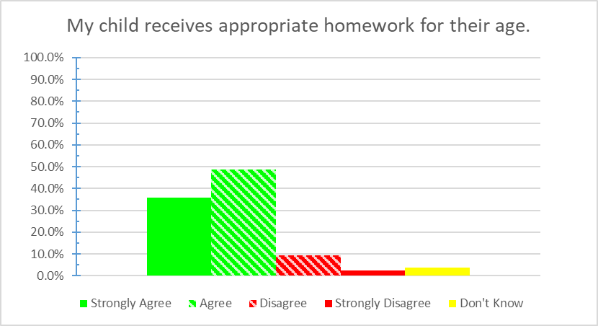
Chart 6: Parent response to 'My child receives appropriate homework for their age.', 2019 Parent Questionnaire.
84.6% of parents responding believed their child received homework appropriate to their age, with 35.8% saying they strongly agreed.
9.3% of parents responding did not feel their child received homework appropriate to their age, and 2.5% said they strongly disagreed. 3.7% of parents responding did not know if the homework their child received was appropriate to their age.

The School makes sure its pupils are well behaved.
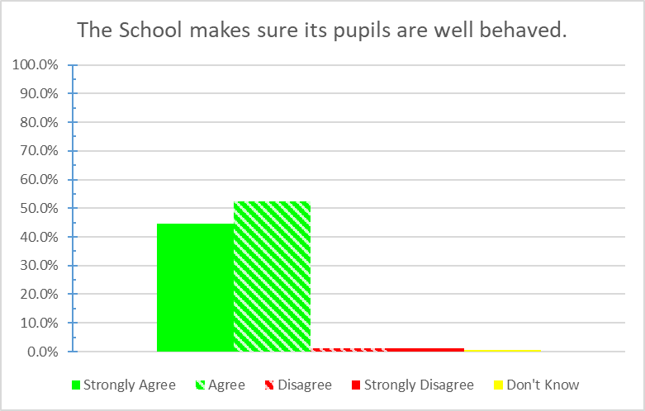
Chart 7: Parent response to 'The School makes sure its pupils are well behaved.', 2019 Parent Questionnaire.
97% of parents responding believed the school ensured good behaviour from its pupils, with 44.5% saying they strongly agreed.
1.2% of parents responding did not feel the school ensured good behaviour from its pupils, and 1.2% said they strongly disagreed. 0.6% of parents responding did not know how well the school ensured pupils’ behaviour.

The School deals effectively with bullying.
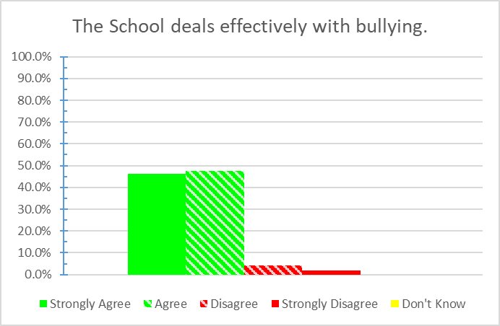
Chart 8: Parent response to 'The School deals effectively with bullying.', 2019 Parent Questionnaire.
93.9% of parents responding believed their child the school dealt with bullying effectively, with 46.3% saying they strongly agreed.
4.3% of parents responding did not feel their child the school dealt with bullying effectively, and 1.8% said they strongly disagreed.

The School is well led and managed.
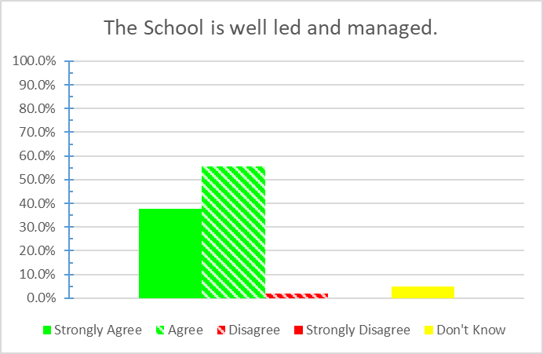
Chart 9: Parent response to 'The School is well led and managed.', 2019 Parent Questionnaire.
93.3% of parents responding believed the school was well managed and led, with 37.8% saying they strongly agreed.
1.8% of parents responding did not feel the school was well managed and led, and 4.9% of parents responding did not know how well led or managed the school was.

The School responds well to any concerns I raise.
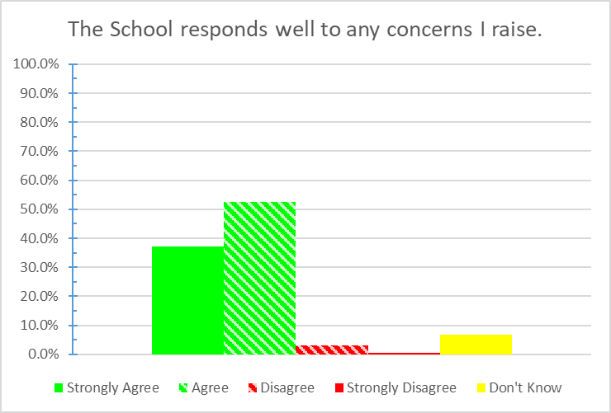
Chart 10: Parent response to 'The School responds well to any concerns I raise.', 2019 Parent Questionnaire.
89.6% of parents responding believed the school responded well to their concerns, with 37.2% saying they strongly agreed.
3% of parents responding did not feel the school responded well to their concerns, and 0.6% said they strongly disagreed. 6.7% of parents responding did not know how well the school would respond to any concerns they raised.

I receive valuable information from the School about my child's progress.
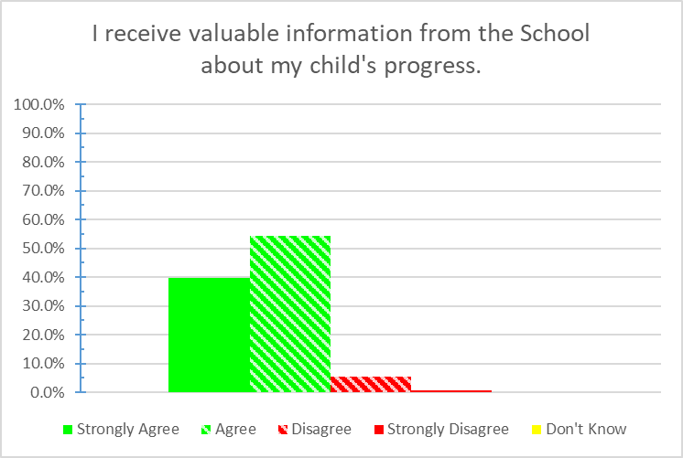
Chart 11: Parent response to 'I receive valuable information from the School about my child's progress.', 2019 Parent Questionnaire.
93.9% of parents responding believed they received valuable information about their child's progress, with 39.6% saying they strongly agreed.
5.5% of parents responding did not feel they received valuable information about their child's progress, and 0.6% said they strongly disagreed.

I would recommend the School to another parent.
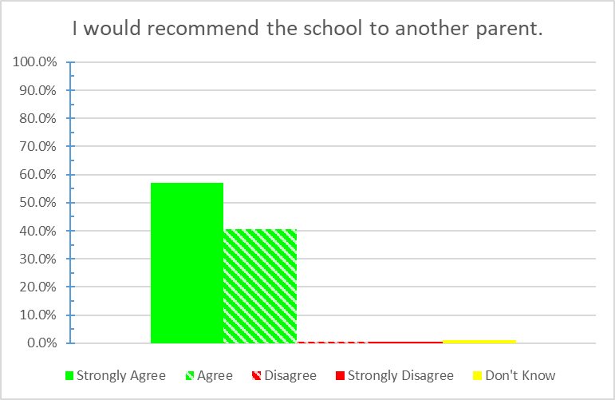
Chart 12: Parent response to 'I would recommend the school to another parent.', 2019 Parent Questionnaire.
97.5% of parents responding would recommend the school to another parent, with 57.1% saying they would strongly recommend it.
0.6% of parents responding would not recommend the school to another parent, and 0.6% said they strongly disagreed.

What do we do well?
A sampling of parent responses to ‘What do we do well?’ include:

Nursery
Keep on top of things for the children … keep [parents] updated
Can always talk to members of the staff without appointment … [nursery] staff are excellent with communication … [staff go] above and beyond .. expectations.
St. Anne’s is a great school … great teachers and assistants who seem to genuinely care … lots of extra activities and trips
Regular feed back about my child’s progress / time at [school].
… safety and attention that is given to [my child].

Reception
[My child] adores school .. I can see how well she is coming along.
Always have time for parents
[The staff] are happy and welcoming.
[Our child] is happy going in to school and has settled well … [Reception staff] are so welcoming and do a great job!
Have always recommended the school … very pleased always
Make the children feel welcome coming into school
Excellent communication with parents … Out of hours provision … Rich and varied lessons … Excellent staff

Year 1
Children feel welcomed & loved … a real family atmosphere
All staff friendly and approachable
Everything – kids love going to school and are sometimes unhappy when they have to come home.
Always good communication [from] the staff. Always consistent with homework. [The staff are] very caring, very understanding of children who have not had a good start in life. They always go above and beyond.
My child is very happy at school and progress is brilliant. Very pleased.

Year 2
A strong focus on making solid academic progress has been noticed this year. The real strength has been the variation in the curriculum.
I’m really happy how [my child] has been integrated into this school.
This year [my child’s] confidence and self-esteem has increased due to the support and approach of his class teacher… Communication has improved.
St. Anne’s Stanley is one of the best schools in Merseyside.
Very understanding teachers and reception staff. I don’t know what I would’ve done without their help over the years.

Year 3
Excellent staff ... have made my child feel safe and comfortable and have helped him progress.
Teaching staff have helped build my daughter’s confidence.
The after school things are great.
[My child] has made a lot of progress in her work and the staff are very helpful.
May child is well supported and St. Anne’s are very supportive of any concerns I have.

Year 4
We have never had any issues or concerns with the school. Any minor incidents involving out child have been dealt with well. We really like the teachers – always welcoming and put you at ease.
The school provided a caring, nurturing environment where all pupils seem happy.
Helping the more disadvantaged children in school, prevention of bullying.
[My child] is very happy in school and I have had no concerns at all.
Value every child as an individual.

Year 5
Our children enjoy school and look forward to coming in each day. … a variety of afterschool clubs and activities [our child] seems to attend something most nights.
St. Anne’s teaches the kids well and always makes sure children are happy ... So happy with [our child’s] progress.
School environment and teachers’ support is very positive and welcoming.
Good variety of after school clubs. Child is engaged and learning well.
Staff in school office are always very helpful, much better to have a calendar of events in advance!

Year 6
My child is happy in school and has enjoyed the years in St. Anne’s. He’s looking forward to the next chapter of life.
Teaching.
Good choice of after school clubs and sporting activities during the day, breakfast club, music, attendance incentives.
The children receive a well rounded education based on caring and learning about those around them.
The older children are given responsibilities which enables them to grow and mature. Pastoral care is fantastic.
Care for and nurture children.

What can we do better?
A sampling of parent responses to ‘What can we do better?’ include:

Nursery
I can’t honestly say I have any worries or disappointments … 100% pleased with all aspects of the school.
N/A

Reception
Nothing.
More homework … children in other schools’ Reception get lots more
communication with staff ... at pick up or drop off ... difficult to catch each other
more trips out
… more pictures on the class website. Not everyone has Twitter
Language lessons … more [after school clubs] would be great … see more examples of child’s school work

Year 1
Reduce homework as … children work well and hard … in class.

Year 2
We are concerned that lessons like French stopped.
Maybe set homework throughout the week rather than just Friday.
Could Year 2 children be included in Reading Plus as well?

Year 3
More [Maths] homework for children please.
More options for school dinners, regardless of which children are sitting first or last.
More healthy options for ‘hot’ dinners.

Year 4
Would be nice if the children had more school trips.
I would like to see the school offer after school clubs, instead of using a subcontracted service which is costly to parents who work full time.
Less homework.
More after school activities.

Year 5
Extra activities and trips.

Year 6
Nothing

